**CS4704 Software Engineering Capstone**

Spring 2016



**BetterU**

“Be you, but better”

|  |  |  |
| --- | --- | --- |
| Julia M. Binger  Mykhaylo D. Bulgakov  Allan F. Chua  Duke J. Forsyth  Filip D. Gouglev | Amanda J. Kahn  Mukund A. Katti  Travis M. Lu  Corey S. McQuay  Ojas D. Mhetar | Ryan T. Munz  Benjamin F. Robohn  Jared J. Schwalbe  Timothy T. Street  Hung T. Vu |

Department of Computer Science

Virginia Tech

Blacksburg, VA 24061

Date: May 1, 2016

Team Number: 1

Submitted to: Prof. Osman Balci

EXECUTIVE SUMMARY

This report will discuss the many steps necessary to design and develop the application, BetterU.  The sections of this report include: Software Life Cycle, Problem Specification, Requirement Specification, Architecture Specification, Design Specification, and Delivered Software.  Following the software life cycle, a problem domain was established, which led to the group coming up with a problem specification for BetterU.  This specification stated the problem that BetterU was trying to solve, but not how specifically it would be solved.  Once that was established, a list of requirements was created for the BetterU application to accomplish.  After this, more specific architecture could be planned.  The architecture decided on included CLOUD FEATURES and MOBILE SOFTWARE FEATURES.  The next step after a back-end design, was the design of the application.  Once everything was planned, development began, which led to the delivered software in the form of an iOS application as well as cloud software application.

Cloud Features:

1. User CRUD Operations
2. DB Timer feature to store progress of the user based on a time period, starting with day
3. Emailing services
4. Graph Displaying on User Progression
5. Making an api from the database to make api calls on the client side (Jax-Rs) for user information and challenges
6. Reading from multiple API’s
7. Storing and retrieving user logged data into a database
8. Made a database to issue challenges on the client side.

Mobile Software Features:

1. Pulling data from the user’s iOS device’s HealthKit
2. Exploding menu for shortcuts
3. User Crud Operations
4. Reading from multiple API’s to view and store user preferred data
5. Graphs to display user health data
6. Storing and retrieving user logged data into a database

**TABLE OF CONTENTS**

EXECUTIVE SUMMARY ii

1. SOFTWARE LIFE CYCLE 1

2. PROBLEM SPECIFICATION 2

3. REQUIREMENTS SPECIFICATION 3

3.1 Enter/Change Goals 3

3.1.1 3

3.1.2 3

3.1.3 3

3.1.4 3

3.2 Have reminders for logging exercises and calories 3

3.2.1 3

3.2.2 3

3.3 Be reminded of goals (via push notifications) 3

3.3.1 4

3.3.2 4

3.4 Get points for meeting goals 4

3.4.1 4

3.4.2 4

3.4.3 4

3.5 View Recommended Foods 4

3.5.1 4

3.6 Select Recommended Foods 4

3.6.1 4

3.7 Track calories, grams of fat, sodium etc. daily 4

3.7.1 4

3.7.2 4

3.7.3 5

3.8 Enter information via Barcode 5

3.8.1 5

3.8.2 5

3.9 Enter Food Consumed To Log Calories 5

3.9.1 5

3.9.2 5

3.9.3 5

3.10 Enter food item and receive nutritional info 5

3.10.1 5

3.10.2 5

3.10.3 5

3.11 User Account Creation 5

3.11.1 6

3.11.2 6

3.11.3 6

3.11.4 6

3.12 User Account Deactivation 6

3.12.1 6

3.12.2 6

3.12.3 6

3.12.4 6

3.13 Edit Account Settings and Preferences 6

3.13.1 6

3.13.2 6

3.13.3 6

3.13.4 6

3.13.5 7

3.13.6 7

3.13.7 7

3.13.8 7

3.13.9 7

3.13.10 7

3.13.11 7

3.13.12 7

3.14 Change Password 7

3.14.1 7

3.14.2 7

3.14.3 7

3.14.4 7

3.14.5 7

3.14.6 7

3.14.7 7

3.14.8 8

3.14.9 8

3.15 Storing the User’s progression throughout a period of time 8

3.15.1 8

3.15.2 8

3.16 Construct Graphs from User Account Information 8

3.16.1 8

3.16.2 8

3.16.3 8

3.16.4 8

3.16.5 8

3.16.6 8

3.16.7 8

3.17 Log in/out 8

3.17.1 9

3.17.2 9

3.17.3 9

3.17.4 9

3.17.5 9

3.17.6 9

3.18 Review Graphs 9

3.18.1 9

3.18.2 9

3.18.3 9

3.18.4 9

3.19 Share accomplishments on social media 10

3.19.1 10

3.19.2 10

3.20 Add and Recommend Friends 10

3.20.1 10

3.20.2 10

3.21 Remove Friends 10

3.21.1 10

3.21.2 10

3.22 Challenge friends across social media 10

3.22.1 10

3.23 Deleting Social Media 11

3.23.1 11

3.24 Enter calories burned 11

3.24.1 11

3.24.2 11

3.25 Enter workout intensity and duration 11

3.25.1 11

3.25.2 11

3.26 View example exercises 11

3.26.1 11

3.26.2 11

3.27 Get recommended exercises 11

3.27.1 12

3.27.2 12

3.27.3 12

3.28 Track Running Statistics 12

3.28.1 12

3.28.2 12

3.29 Non-Functional Requirements 12

3.29.1 12

3.29.2 12

3.29.3 12

3.29.4 12

3.29.5 12

3.29.6 12

3.29.7 12

3.29.8 12

3.29.9 12

3.29.10 12

3.29.11 12

4. ARCHITECTURE SPECIFICATION 13

4.1 Operational Diagrams 13

4.2 Client/Server Architecture Diagram 14

4.3 Data Source Tier: 15

4.4 Client Side: 16

4.5 Server Side: 16

5. DESIGN SPECIFICATION 17

5.1 iOS Storyboard 17

5.2 Close Ups of iOS Storyboard and Proto.io 18

5.3 Web Storyboard 46

6. DELIVERED SOFTWARE FUNCTIONALITY 47

6.1 BetterU iOS Application 47

6.2 BetterU Web Application 113

7. CONCLUSIONS 124

REFERENCES 125

TEAM MEMBER CONTRIBUTIONS 126

PROJECT GRADING 127

# SOFTWARE LIFE CYCLE

A **good software engineer** develops software by following the software life cycle shown below.



A **programmer (hacker or ad-hoc developer)** develops software by looking at the problem and directly coding in an IDE. This approach is known as the **Build-and-Fix Approach**, which must never be used!

# PROBLEM SPECIFICATION

In today’s society, it is very popular for people to make New Year’s Resolutions to improve their physical health. They set goals to eat better, lose weight, or gain muscle, but often these goals never get achieved. Most people end up losing motivation and giving up after about 2 weeks into the New Year because they don’t see immediate results. Other times, they try out "fad" diets, diet pills, or supplements that are ineffective, unhealthy, and ultimately fail.

People who truly want to change to a positive healthy lifestyle must understand that it all comes down to the number of calories taken in through eating and the number of calories used through physical exercise and activity. Having a committed diet and exercise program is crucial to success. However, there is currently no platform for collecting and tracking caloric intake/outtake, meals consumed, and workouts completed. There are many health applications on the market, but none truly provide a full snapshot of that person’s health.

There are also no applications on the market that allow users to explore healthy food and workout options that are in line with their fitness goals, progress, and lifestyles. An example of this would be an application that takes note of a user’s target caloric intake based on their BMR and goals and then gives them some different meal recommendations based on how many calories they need to consume. More specifically, if the user already consumed 1500 calories for the day and is on a 1800 calorie diet, the program can take what it knows about the user preferred foods and recommend a 300 calorie meal or two 150 calorie small meals. Similarly, the program would recommend workouts to the user to burn excess calories based on their current caloric intake/outtake for the day and fitness goals.

The stakeholders and decision makers who would be interested in the solution of the problem would be people who want to change and better themselves physically through diet and exercise.

An application that allows these people to organize and manage these goals and gives them the knowledge and recommendations necessary to accomplish them would make getting healthy easy. This would best be achieved through a cloud/mobile/web app that can store the data of users persistently and allow them to log and view their progress, goals, and health data and recommendations.

# REQUIREMENTS SPECIFICATION

The requirements specification phase of BetterU involved researching other nutritional and fitness applications such as “My Fitness Pal” and asking other students what they would like to see in a nutritional and fitness application. Once the team gathered all the raw information, the information was then broken down and user stories were created. From the user stories, the team was able to create well-defined requirements that BetterU would have to meet. The user stories and their corresponding requirements are listed below. Some requirements are repeated across different user stories.

## Enter/Change Goals

The user shall be able to input fitness goals to personalize their experience within the application. This will allow the user to stay focused during their fitness journey and motivate them to continue working out in order to achieve a better self. The user shall be able to change their goals they have set. The reasons that a user would do this are two-fold the first of is a user surpasses their original goal, the second reason would be a user misjudging how much time they will have to work out during the average week.

### 

BetterU shall allow the user to enter a weight goal of either losing weight, maintaining weight, or gaining weight.

### 

BetterU shall allow the user to enter distance/weight lifting goals, as well as amount of weight.

### 

BetterU shall allow the user to enter short term and long term goals. There shall be goals monthly, yearly, and an end goal.

### 

BetterU shall allow the user to enter/change their goals in the user account information tab/page.

## Have reminders for logging exercises and calories

BetterU shall allow users to set personal goals. Some users will want to lose weight while other users will want to gain muscle etc. BetterU will then remind the user to log any exercise and log any calories consumed daily. This way the user can be given better recommendations using the collected information.

### 

BetterU shall remind user to log consumed calories

### 

BetterU shall remind user to log completed exercises

## Be reminded of goals (via push notifications)

The user will be able to set their goals thus they must be able to receive notifications for said goals. For long term goals the user shall be able to set thresholds on said goal so they will get reminded of their current progress. An example would be if a user had an achievement of losing 50 pounds and they lost 25 pounds, they should get a reminder.

### 

BetterU shall remind the user of his/her goals at set intervals.

### 

BetterU shall allow the user to set/modify notification intervals

## Get points for meeting goals

Users will receive points for completing goals. The larger the goal, the more points rewarded. We’re confident that gamification will increase motivation for completing and maintaining goals.

### 

BetterU shall reward varying point values for completing goals.

### 

BetterU shall reward points for completing daily, weekly, and monthly challenges.

### 

BetterU shall share scores with friends to promote friendly competition.

## View Recommended Foods

This application will be able to recommend food/recipes based on the user’s goals and current caloric intake of the day. Recommended foods will also consider the current meal of the day, and if requested, can offer popular foods for that meal.

### 

BetterU shall recommend what to eat based on goals and current caloric intake.

## Select Recommended Foods

Once the user selects a food recommended to them, the application will take the food entry in our database and retrieve all nutritional information associated with it. This information will then be added into the user’s daily caloric intake.

### 

BetterU shall be able to access food databases and add the nutritional data from the databases into the user’s daily database.

## Track calories, grams of fat, sodium etc. daily

After the user inputs the data of the food they have eaten, the application will be able to aggregate key metrics such as macronutrients (protein, carbohydrates, and fats), as well as sodium, vitamins, etc. These will be broken down on a daily chart so the user has a summary of the nutrition they eat each day.

### 

BetterU shall allow users to view charts/graphs regarding their progress.

### 

BetterU shall collect user information regarding their current nutrition and goals.

### 

BetterU shall allow users to view key metrics based on foods eaten.

## Enter information via Barcode

A user on the mobile app can use our application to scan a barcode and receive the information about that food. This decreases much of the hassle presented by entering nutritional information, and helps the user make healthy choices.

### 

BetterU shall allow users to log calories by specific food item

### 

BetterU shall allow users to log food items from packages barcodes.

## Enter Food Consumed To Log Calories

A user wants to enter food items into the application to log calories consumed. BetterU shall search the USDA’s National Nutrient Database based on user’s food search. Once the food item is found and selected, the application will update the number of calories consumed on that day for that user. The new consumption data will also be added to the Progression Database.

### 

BetterU shall allow users to log calories consumed or burned.

### 

BetterU shall allow users to search for and select food items from the USDA’s national nutrient database.

### 

BetterU shall provide a tab specifically to enter in food information.

## Enter food item and receive nutritional info

The user shall be able to search for food items via Yummly on our application and then receive recipes and their nutritional facts such as calories, ingredients, sugars, proteins, etc. If this information is quick and easy to access then the user will be more inclined to research the facts about what they eat before they put it in their body.

### 

BetterU shall allow the user to search for nutritional info based on name of food.

### 

BetterU shall utilize the Yummly API for the nutritional info.

### 

BetterU shall allow users to get recipes via Yummly API.

## User Account Creation

User downloads BetterU from the Apple Store, hoping that he can finally organize his workout routines. The user opens BetterU and decides to create an account. The application then prompts the user to enter his username, password, height, weight, age, and weight goals.

### 

BetterU shall allow the user to create an account with a username, password, height, weight, weight goals, gender, and age.

### 

BetterU shall allow the user to maintain their account with the option to change their personalized data.

### 

BetterU shall allow the user to have their account recorded into a cloud database, so that they are able to take their account with them on any mobile devices.

### 

BetterU shall send an email regarding account activation.

## User Account Deactivation

A user who has achieved their desired goal decides to delete their account. The application should make this a simple process. All the user has to do is select ‘Delete Account’ in the menu and their account will be deactivated.

### 

BetterU shall change a user’s account to ‘inactive’ in the database upon deletion

### 

BetterU shall leave the user information in the database, in case of reactivation.

### 

BetterU shall have a ‘deactivate’ button in the settings menu.

### 

BetterU shall send an email regarding account deactivation.

## Edit Account Settings and Preferences

The user will be able to change how frequent the push notifications appear and what he/she is notified about, what BetterU emails the user about, reset user data, change profile information (Height, Weight Age, Sex, and Weight Goals), Set regiment type (Lose Weight, Maintain Weight, Build Muscle).

### 

BetterU shall allow user to change the frequency of push notifications from Monthly, Weekly, Daily, or every 4 hours

### 

BetterU shall allow user to change the frequency of email notifications from Monthly, Weekly, Daily, or every 4 hours

### 

BetterU shall allow user to change whether he/she is notified about goal reminders via email and/or push notifications

### 

BetterU shall allow user to change whether he/she is notified about friends’ achievements via email and/or push notifications

### 

BetterU shall allow user to change whether he/she is notified about enter daily log information via email and/or push notifications

### 

BetterU shall allow user to reset nutrition and workout data

### 

BetterU shall allow user to change their height

### 

BetterU shall allow user to change their weight

### 

BetterU shall allow user to change their age

### 

BetterU shall allow user to change their sex

### 

BetterU shall allow users to create/edit weight goals

### 

BetterU shall allow user to select between regiments of lose weight, maintain weight, build muscle, or improve cardio

## Change Password

The user has decided to change his/her password either because they want a new password or they have forgot their current password and need to reset their password. The user will have to enter their current password once and the type in the new password twice to confirm it was typed in correctly. If user forgot their password, then they will hit the reset password button and an email will be sent with a temporary password to the email in the user’s account information. The user will then proceed as before, but use the temporary password instead. The user will be prompted to change their password upon successful logging in.

### 

BetterU shall ask the user to give a valid email address during account creation.

### 

BetterU shall ask the user to enter account name/email address when requesting temporary password.

### 

BetterU shall ask the user to enter current/temporary password once.

### 

BetterU shall ask the user to enter new password twice.

### 

BetterU shall mandate that a password shall contain at least 2 numbers, 2 lower case characters, 2 upper case characters.

### 

BetterU shall allow users to enter a password with special characters.

### 

BetterU shall mandate that all passwords be 8 to 25 characters in length.

### 

BetterU shall have a reset password button/link to get temporary password.

### 

BetterU shall automatically create a temporary password and send the password to the user via email when requested by the user.

## Storing the User’s progression throughout a period of time

BetterU will have a progression database which will store the User’s progression of calories consumed while logged in. This allows the user to see if the user is meeting their goals, and what should be done for their progression.

### 

The server side of BetterU shall store the user’s information to track their caloric intake, weight loss, physical activity, and logged exercises.

### 

The user shall store the information into the application and the application will store the user information into the appropriate database.

## Construct Graphs from User Account Information

The server-side of BetterU will retrieve information regarding calories consumed, minutes active, etc. from user records in the Progression Database. From this data, BetterU will generate graphs giving users a visual representation of their progress. Data will be displayed via line/bar graphs, where previous dates are along the x-axis.

### 

The Progression Database shall provide information about specific users by day to the server-side application

### 

BetterU shall record information about user activities by recording it in the Progression Database

### 

BetterU shall provide a separate tab for viewing graphs/user-related data

### 

BetterU shall provide functionality to allow the user to scale the viewport of the graphs (i.e. view over different periods of time)

### 

BetterU shall provide graphs of varying types to the user, such as minutes active, caloric intake, etc.

### 

BetterU shall allow users to view charts/graphs regarding their progress

### 

BetterU shall construct graphs from user account data showing user trends over time

## Log in/out

The user logs into their account by supplying a username and password that is associated with their account preferences and data stored in our users database. The user will be prompted to log in when they first open BetterU. They can either log out manually at any time, but will remain logged in if they close BetterU without logging out. If the user wishes, they may toggle their settings to log out automatically every time BetterU is fully closed.

### 

Each user shall have a username and password that serves as a key into the user database, which holds all of the data for that particular user.

### 

The user shall be able to enter their username and password that they can enter into the appropriate fields on the login screen to reach the home screen of BetterU and have access to all of their user data and preferences.

### 

The user shall be able to log out during their session to close all views of the application and disallow access to any screens besides the login screen. After “Log Out” is clicked, no more user information is accessible from the device until a new login is processed.

### 

The user shall be able to access the “Log Out” button within 2 clicks from anywhere in BetterU.

### 

The user shall be prompted to log in to BetterU from the login screen if and only if it is their first time opening the application or the last thing the user did was log out.

### 

The user shall be able to go to the settings screen and select “Log Out On Close,” which shall make the application simulate the action of a manual log out whenever the user fully closes the application, in order to preserve their privacy if desired.

## Review Graphs

The user logs their calories in/out and active minutes over time and is able to go to the data section of the application to look at how these have changed over time. The graphs are generated based on the user data stored in their associated account. The user is able to easily interpret and see trends in the data from the home screen of the application. To see how trends in the data, they can adjust the scope.

### 

BetterU shall allow the user to be able to view how the data they log has changed over time according to net calories and active minutes.

### 

BetterU shall allow the user to be able to adjust the scope of the graph from day, week, month, to all time to see their progress.

### 

The graphs of the data shall be viewable from the home screen of BetterU.

### 

The default view of the data on the home screen shall be of the calories in/out and active minutes of the current day as two separate graphs.

## Share accomplishments on social media

Imagine being rewarded for eating healthy, exercising, and meeting set goals. BetterU would like to create an environment where users earn points, trophies, and other bonus features for meeting set goals. For this reason, a user who embraces this feature may want to share the progress they’ve made with friends and family on Facebook, Twitter, Tumblr, etc. Users who use social media regularly can find this as an incentive.

### 

BetterU shall allow the user to be able to share points and trophies they’ve earned from eating and exercising on Facebook, Twitter, Tumblr, etc.

### 

BetterU shall allow the user to be able to share nutritional and exercise summaries from BetterU (such as miles walked or calories burned for a given week) on Facebook, Twitter, Tumblr, etc.

## Add and Recommend Friends

Users may add friends from social media such as friends on facebook. The user is then able to send recommendations to their friends to join BetterU via social media.

### 

BetterU shall allow the user to populate their friends list via social media.

### 

The application shall allow the user to recommend their friends to join BetterU.

## Remove Friends

Users should be able to remove friends from their friends list. By clicking on settings, the user is able to search for specific people to remove from his friends list. The user may block some friends from trying to add the user again.

### 

BetterU shall allow the user to delete data from their friends list under settings

### 

BetterU shall allow the user to block people from ever adding them again

## Challenge friends across social media

Users can challenge each other on Facebook, Twitter, Tumblr, etc thru BetterU to other users to see who can meet a goal first to earn more points. Everyone can pursue their goals at their own pace so the focus is on who can meet their goal first. Those who want motivation to meet goals can find this feature useful.

### 

BetterU shall allow the user to be able to challenge a random user or a friend on Facebook, Twitter, Tumblr, etc to meet a goal first and earn points if one wins.

## Deleting Social Media

Should a user wish to they may hide their progress and to disable their access to social media. Through the settings menu the user can remove social media accounts and keep everything private.

### 

BetterU shall allow users to remove social media connections

## Enter calories burned

Users shall be able to keep track of the calories burned during workouts. This shall allow the user to chart their progress. The information will be used with the user’s nutritional intake so that they can manage their fitness goals.

### 

BetterU shall allow users to log calories consumed or burned

### 

BetterU shall allow users to view charts/graphs regarding their progress

## Enter workout intensity and duration

Users shall be able to measure how many calories are burned based on the exercise and the time interval.

### 

BetterU shall allow users to log calories consumed or burned

### 

BetterU shall allow users to view charts/graphs regarding their progress

## View example exercises

The user shall be able to browse through a catalog of exercises to gauge the difficulty and purpose of the exercise. The user shall also be able to determine how the movement is performed.

### 

BetterU shall display a catalog of exercises that shows how movements are performed, difficulty of each movements, and the muscle/muscle groups targeted.

### 

BetterU shall allow the user to search through a catalog of categories based on muscle group.

## Get recommended exercises

The user shall be able to see recommended exercises based on the user’s specific fitness goals. The exercises will vary in difficulty and provide the user with options that they feel most comfortable with.

### 

BetterU shall recommend workouts based on the user’s goals.

### 

BetterU shall allow users to enter in injuries so that no dangerous workout recommendations are made.

### 

BetterU shall allow users to enroll in workout plans and get reminders about them

## Track Running Statistics

Users who run or jog as an exercise will be able to track the time and distance they spend for each session.

### 

BetterU shall allow users to track their run time and distance.

### 

BetterU shall be able to plot the route on a map.

## Non-Functional Requirements

### 

BetterU shall be Royalty-Free and be developed through open-source technology

### 

BetterU shall remember mobile devices and allow users to automatically login if they have cookies enabled

### 

BetterU shall make database queries no longer than 2 seconds

### 

BetterU shall hide user’s personal and account info from developers and other users

### 

BetterU shall prevent users from accessing other user's profiles

### 

BetterU shall make recommendations based on user’s preferences and are in accordance with our nutrition database.

### 

BetterU shall be available on Web and iOS

### 

BetterU shall not break any privacy laws

### 

BetterU shall have Terms and Conditions for use of app

### 

BetterU shall be usable offline and Sync with the cloud when app reconnect

### 

BetterU shall allow user to enter food/workout and other updates in under 20 seconds

# ARCHITECTURE SPECIFICATION

## Operational Diagrams

The following operational model, Figure 1, depicts how the User gets information about their data. First, the user enters their health data through whichever mode they see fit (mobile or web) and submits it to the BetterU system. In the cloud, the system looks up the workout or food that the user has entered and translates it into calories. The appropriate field of the progress database is then updated to reflect this information. When the user goes to view their progress data, our application grabs their progress entries from the database in the cloud and renders a graph of the results over time.

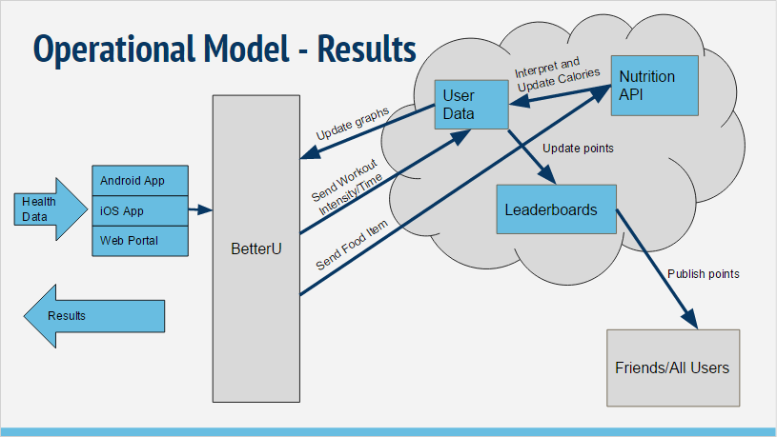

Figure 1: The operational model diagram of how the user gets results from BetterU

The following operational model, Figure 2, depicts how BetterU originally planned to implement recommendations. In this model, the user inputs their goals in regards to workout and nutrition, and BetterU would return recommendations that were classified in accordance to those goals. However, in the final version of BetterU recommendations are not handled this way. Instead, in the food logging tab meals are classified by caloric tiers and users are allowed to browse the options and add them to their food plan for the day. Similarly, in the workout logging tab, workouts are classified by muscle group and users are allowed to browse the options and add them to their workout plan for the day. This method was chosen to give users more free will in decided which meals and workouts were most appealing to them, instead of BetterU giving them a random recommendation that they were not interested in.

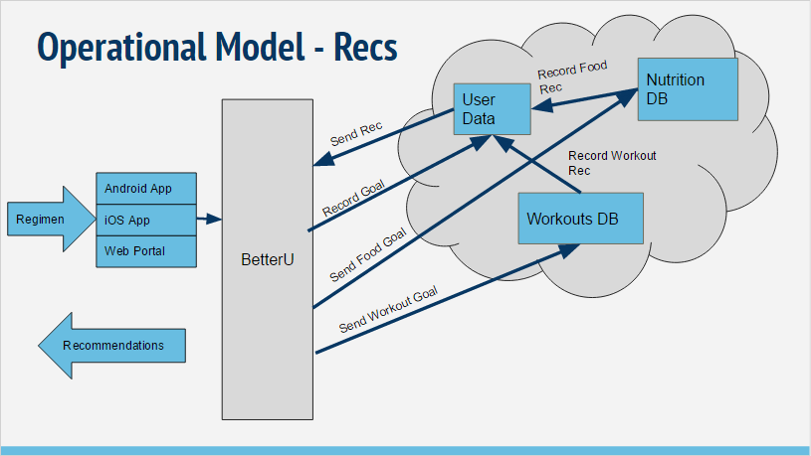

Figure 2: The operational model for the recommendations provided by BetterU

## Client/Server Architecture Diagram

BetterU uses a Client/Server Based Architecture. Users interface with the mobile and web applications, when sends requests through the cloud server to create, modify, or receive data from the APIs and databases used by Better U. Figure 3 below depicts the transmission of this data, followed by descriptions of each level of the architecture.

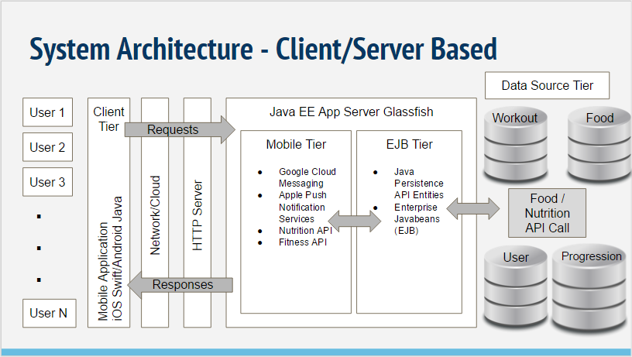

Figure 3: Diagram of the client/server architecture for BetterU

## Data Source Tier:

Yummly API: <https://developer.yummly.com/>

* Provides recipe information for the recommendation system

USDA API: <https://ndb.nal.usda.gov/ndb/api/doc>

* Provides nutritional information for specific food items used to look up caloric intake

Nutritionix API: <http://www.nutritionix.com/business/api>

* Translates food barcodes into nutritional information used to look up caloric intake

Wger API: <https://wger.de/en/software/api>

* Provides workout information used for the recommendation system

User DB

* Keeps track of user information, preferences, food plans, and completed challenges

Progress DB

* Keeps track of user steps, miles, calories in, calories out, and weight over time

Challenges DB

* Stores challenges that we created as well as tracks user progress through these challenges.
* Tables for Weekly and Daily Challenges, as well as a User Index table which keeps track of where each user is in the sequence of daily/weekly challenges.

## Client Side:

* Android and iOS applications available for smartphones. A web interface will not be supported.
* The client will be sending requests to the server sides at times when the user wants specific information or when to log-in.
* XCode and Android studio as the IDE for the front-in.

## Server Side:

* “The Cloud”
* We will be using Java EE (w/ NetBeans IDE)
* Three MySQL Databases
* APIs to access workout and nutrition information

# DESIGN SPECIFICATION

The team used Xcode to design the storyboard for the iOS application as well as proto.io. Proto.io provided a friendly interface to create mock screen for our iOS application so that the team could finalize the look and layout of BetterU.

## iOS Storyboard

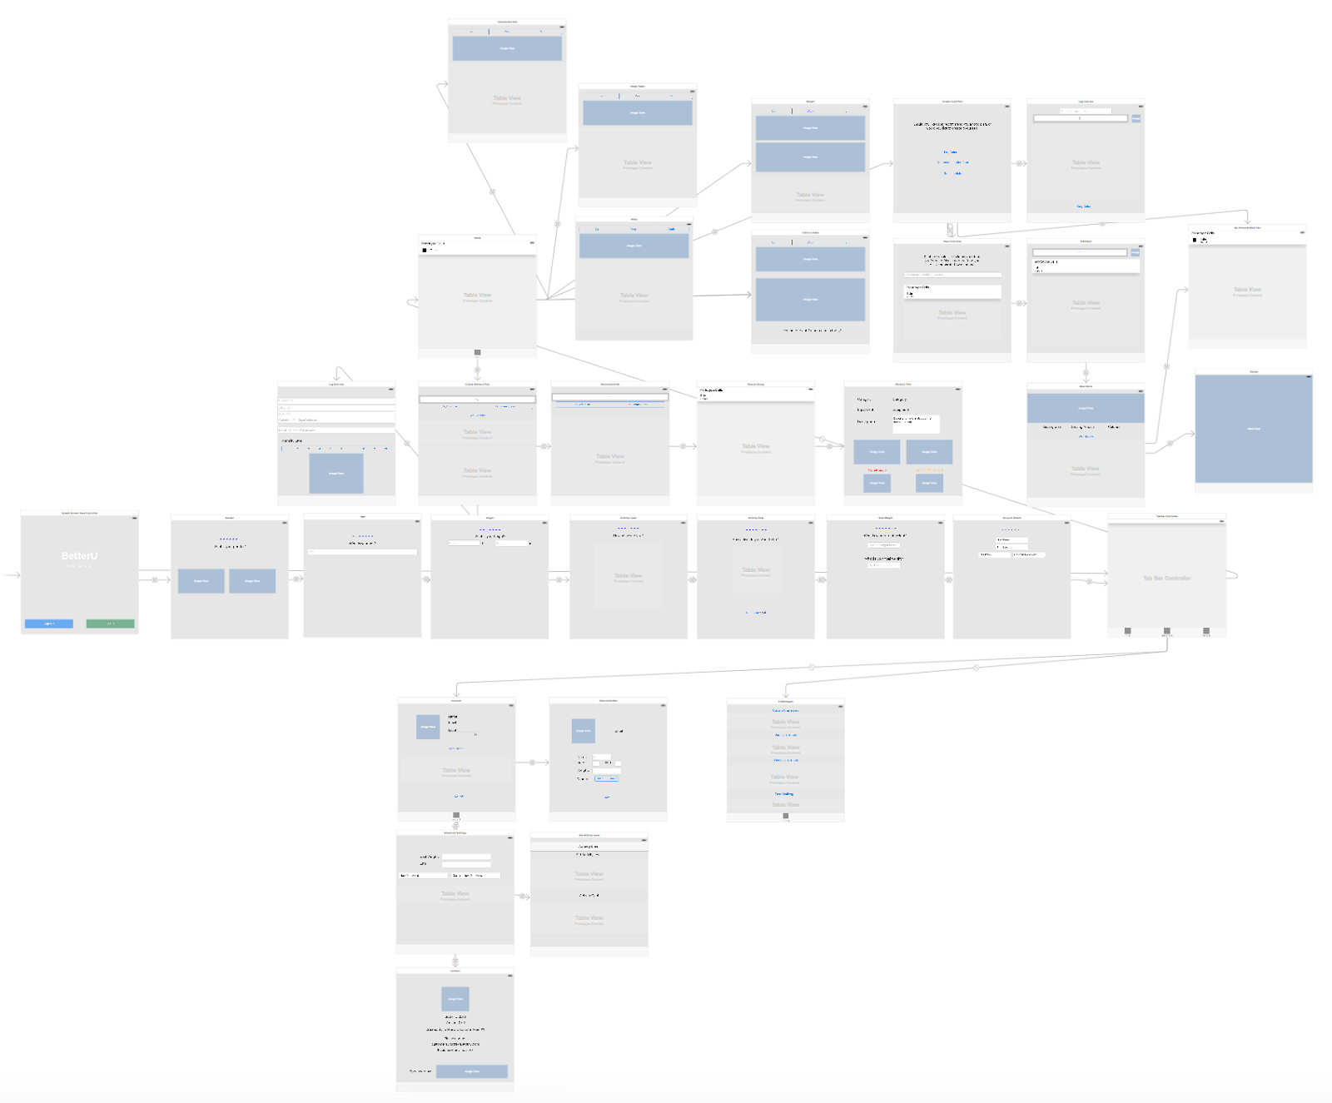

## Close Ups of iOS Storyboard and Proto.io

|  |  |
| --- | --- |
| https://lh5.googleusercontent.com/YamFQgNtXGWNid57KE_azLZemaShGKCfbA3qVi0INmW4utQe-IkvBCoQ3TuokalWDT-czRqu8mciH0SZYmH_e0SzACDelXZDqZ5PC2bt1KzI8cIwzEEnEtArrSFr1nwDssqVc7k_  Figure 4: The home screen | https://lh4.googleusercontent.com/WlhiJFQjrZLHBA-QylBH12LN6qxQGxHQEw-T1EbLgUh4Q-akkX1zjmg6FAnVeNXe8q80lCqFS85f-kVK797m5usl8motdej-cWzMgUPBsQj6WpfgDoqzGR8z6-Dj6ih-TQSqarp6  Figure 5: The sign in screen |
| https://lh6.googleusercontent.com/GquexWHVUduPZnQe8t8pzz_EyBKEyOtqiEdcNw76DaPm3gXwx_cl23ui7CXZatIm5HJJoLfj7jhJ_TStI7BcT1KX61FVpU-VLIRpg6UU7n6OZnqmlPpO4CiZxEVK3egNfwWpyyiQ  Figure 6: The home screen storyboard | https://lh5.googleusercontent.com/ViCwBWwOogsNbm7C6mBR8Xz-W0csquQIe75XiSJuSlOIyMBrC_rsMx6CQYWJrvGzIQ1kyUEr76NK5qgrDIry-M7COiJsNpt3_3H5Pt0OOUJrzTkJhSc_WnHd0iHrNHzo5Ti6iB0A  Figure 7: The sign in screen storyboard |

The images above show the design for the splash screen and the login page. If a user already has an account, they can enter their username and password. There is a checkbox/toggle that the user can use to remember their username and password. The existing user can then hit the login in button after entering their credentials to proceed to the home screen. There is a sign up button for those who do not already have a BetterU account that will take them to a questionnaire to begin the sign up process. There is also the option to sign in or sign up with Facebook.

|  |  |
| --- | --- |
| https://lh5.googleusercontent.com/BqZpOfWO4gkJnst5pLTnstaGyFq5Duv__xDLfPUZWrOb_5aY9_V_-NC4mBbNp_ef10rAgVBXl97m_AlEs9rGz_bmkwKXH64iFOS_s6BlnyyjmlJ-3zoRBMqrosbib_p-NzK2OHuU | https://lh5.googleusercontent.com/jnxZZlhg7NNNTjFhFAXgm8-wweJydX3EstuErm_z4ZoRJoxhsziq0HcAeSmuTIf6FEfzgWeMqjf2GcLcB5wi5jX5l-QDEs-9tEmvyH95lNTG2BIzfFmJ9PHPzANMJ82Dm7jT6CQ_ |

Figure 8: The gender question screen

The screen in Figure 8 is reached when a new user hits the sign up button on the previous page. The user has the option to select their gender by clicking on one of the images. The user’s gender is important because the nutrition and fitness information provided by our application will be slightly different for each gender.

|  |  |
| --- | --- |
| https://lh5.googleusercontent.com/kss0XfCKAty0RauIcRjSeb-NDajCwxSZx03RJTeUaB2YLHDzU2TE3uyrfD1Cc7IkfFYUMZPqNrtH-g-8tN2k4Y878KnuBHK3-T0uLXCzhWuC4FXCOqi_f-aiTvFuHrT_0LdZWEco | https://lh6.googleusercontent.com/ZARYtuNjdBubDO2VgFEd8ljcYuPabUKRnlxYjIrhoeyPjBuwxuc9A7hJ6CmRno8CMhqi0OgUl6wLPRtKbu2PsE5-wXGrn9701o0SJngfmK76vbEI7_2rgOKdERd2d-tHOeTSJc9G |

Figure 9: The age question screen

The screen in Figure 9 allows the user enters to enter their age into the box and proceed to the next question. The user’s age is important so that BetterU can provide the appropriate nutrition and fitness information.

|  |  |
| --- | --- |
| https://lh3.googleusercontent.com/4fnlGK9scrKH4AuO9FF-vyCrXbXGM6s5-E6pD0EnpEOPSiyXNUt26VwHy5YnwjXbUwXHbiLL8q2tZk4M9amMWA0SO-a40JJTK88m4uPUJ5X6iITz2Urs3Fh8cJZUXmv7UGnIGw8n | https://lh4.googleusercontent.com/0TaB7y4LU56dmsnAhaqV3pkmF7gLbhLa4__jdTIzgQ5R009BL6RB0WBLO48YPWg1vmXDStirWq13lAqsA-xIbBH5hRwiSDLnCPF6dalzXvWTITPfM0RiNco7o6DmRi6b3VKxFSQR |

Figure 10: The height question screen

The screen in Figure 10 allows the user to enter their height in feet. The height information is then used by the system for fitness and nutrition calculations.

|  |  |
| --- | --- |
| https://lh4.googleusercontent.com/PAWzuCItvSNbmnFNM9mJoS8HhH9Kc2bXL_s8qXJW-YLfDk1nMFGrzTtuzlmugAEywmolSzKJrWNeksLpprq22aHpeemeyR0qJHqxSFZK_XIHCUkHXjzAvd2qZV_r8MLceiLqaABh | https://lh3.googleusercontent.com/a1y_4p0hUCjUIB_kgghobopDSVIfgB6IFbDTP1mIMChllGI-9U6j-c-jL7hmzXDHBUMjN0MczVP3Y4HAhxm6zW2jlq9Svl6bWLkmNnNJNVnJWWiebjc7_ELOU1XWJr-CXPuak7AO |

Figure 11: Current activity level question screen

The screen in Figure 11 allows the user to select their current level of activity (sedentary, lightly active, active, or very active). Sedentary is when the user is active for less than 1 hour per week. Lightly active is when the user exercises for 2-5 hours per week. Next, Active is when the user exercises for 5-7 hours a week. Finally, Very Active is when the user exercises for more than 8 hours a week. This information is then used to help determine the appropriate recommendations for the user.

|  |  |
| --- | --- |
| https://lh5.googleusercontent.com/9IDjNAIetSmFjtYCY5MKoL9PNjY6M-7JzKYdTviOE-hY4xecILmY4Zm6Fd8VseDjCr5KXCFp-WBRbdL9pCx7TarcB8hmyP6N_s_KfRZcYGtx_VpLabmoY5KRFeNM6rn3To0G3JGy | https://lh5.googleusercontent.com/sVRvzcyk-wtRshbMjjmjqott60hbd3oBhCp1Boflz-1DB8WZ2_JpbpLp8Cg4TBDD0pAW-vBYXKuvno5mtuYTg_Ht7yzEnmKKE38LBkk3Y_rRBLy3JkIjQ0Hwvxf8vVfDlcYS41YK |

Figure 12: Desired activity level question screen

The screen in Figure 12 allows the user then selects their desired activity level (lightly active, active, or very active).  If user does not know what their desired level is, the user can select “I don’t Know Yet” if they wish to skip and continue with the questionnaire.

|  |  |
| --- | --- |
| https://lh3.googleusercontent.com/fNO7jXUEXLJyAoKBLzW_Hr4Uc-T_p6-cHR9To096uary9gQ2u7WQeFQfcg0evqDgRMHNg5wI6Fgi4z6Z9hdtZOb1NHhdZm6Lg_uQ8zjIprXS5Edr9WZs2sYSe3fm4JDfd7_9IoQN | https://lh6.googleusercontent.com/WUgXRwZhml5NunVtHGxfigfqR5mpF47P8NEYdW6LaM8KnJ7HA3m9DhQcFoBZtrdzO-e2bfv-PttjBDCDXtBqYD9EStsI5AlHEXTatIOPKAKAe1bzMLuZs-r4NKocyS3-GOwa-yzT |

Figure 13: Enter weight screen

The screen in Figure 13 allows the user to enter their current weight in pounds and enter their goal weight that they wish to achieve.  Both weight entries are used for nutrition and fitness calculations and recommendations.

|  |  |
| --- | --- |
| https://lh5.googleusercontent.com/aWX08Og0VQ9V7mJ77LYVEwN3oJds8AA183yj49LR8V7RYomlkhFPYjVjWb2mzSwD9IQoWD9DYVtF3A-ThSwoeQaWFlEdalznGqvv7OvRMiwqH_BRfJ6GCa5If_Nubo8ggfz-XcY0 | https://lh4.googleusercontent.com/uDf5Lg66ZskWcB4cHRHG3PgiE3ypFwKddEoUj0ottVHQdG6Pz7_ajCRIteKMLvSomuVmJ_9BNUFfReCiyiSvHE3Wyj__tdojsjnmUw1xeevrM12JWNp_x8mxA5ovunuoiEEgOc5v |

Figure 14: Account details screen

The screen shown in Figure 14 allows the user to enter a unique username that they wish to go by in BetterU. This name is also shown to other users.  The user must also enter a valid email address that will be used for communication and for account validation.  The user must choose a password that contains at least 2 numbers, 2 lower case characters, 2 upper case characters, and is between 8-25 characters long.  The user must re-enter the same password for confirmation.

|  |  |
| --- | --- |
| https://lh6.googleusercontent.com/SOQgbzks7oh9oXYQJOCLzzOHLJfD5ToIxSR2JLcyu66C4jmaN2F2-7g0JJXT_UdP1klTxGPZXseQVVHY-Sr95gYU_EVrMXzcRj-d2ymZrkL4jAUpqFE7yj0FrJ3leyLVMzmejWtS | https://lh4.googleusercontent.com/KwTwydP7HOMqKxg5bsj8lGnQorrVUzaiI8-y9xIb-Cvm7WopmiBNGUVbIUlUsV3M1hUNNGKF97y6ZvSlO4sT8hscGKBN5d7m9lk-k20iauhRIyvj6bt4LIYBZMfs3uczIUVm7THj |

Figure 15: Home screen

The screen in Figure 15, has the navigation buttons for the Calories Burned screen, the Steps Taken screen, the Miles screen, the Weight screen, the Caloric Intake screen, the Log Food screen, and the Log Workout screen. Along the bottom of the screen, there are shortcuts to the home screen, the challenges screen, and the account screen.

|  |  |
| --- | --- |
| https://lh5.googleusercontent.com/k_VnKbxGgvqEqhNbcWsLJkyixi6Mh1q1W84Ucy58GQWzBkL3nwQhD4moitqqjMFeh8BPTP4BtPkHfffDsTuH6cF3HrRRuuz8Ow-XZN-WOfDN2is8ynBVo4Wa5GUW8cts3hiPINtD | https://lh5.googleusercontent.com/TNJhX9oAq8ZETOhaafW4lGSFle-lrmPRhTNFOAYsKmAj4U1OC0-GQFoxY6GqaZmgjK7ydiahitJDOqdjZ8kG5m1qKoVZ_Xf4jeP725XBDjy2m0LG2p1hiePRck1kDL6uYDLMlOp8 |

Figure 16: Calories Page

The screen in Figure 16 has graphs for the number of calories burned each day, week, and month. A summary of the information presented in the graph is shown below the graph.

|  |  |
| --- | --- |
| https://lh4.googleusercontent.com/VxX70FRuXqcM5Hr4WD0uE2l6aspQ2OrjzVddw0aDF7eeWGxH23Q87ctrCcb7vwski10ybcUKHezL2PGALgSJp1G8UJg-D4pIYtXHWlg-fz-1he9RtN7ZvzxGlOJF0i4PRusPmLI6 | https://lh6.googleusercontent.com/kTt_dKMQLxz0Xipy1e9itXo4ZQRaECc46xMsGC6sw8Uzmdfi9rSp7rP4EjxYwIQZNGOx74nmW3-n70FP67yd6ZoGoYsMnCWwD9-tdpS8q26dGrwP_yy0F9UgUX5fPzpXswfGXxzn |

Figure 17: Steps page

The screen in Figure17 has graphs for the number of steps taken each day, week, and month.  A summary of the information presented in the graph is shown below the graph.

|  |  |
| --- | --- |
| https://lh5.googleusercontent.com/PMLXQintkfzDK_tpl3PvlVH0wxCudhSFmm4lviYshhJSyRggSupkJyx_76NgMjxWMvrjFC8PzpvIaK_CSMOcjWEs7JWyxpHKSYkWr2lmPpWqJisv11SXyvGfQSPMJc3XKjJEuw9s | https://lh5.googleusercontent.com/bW_HFFzxKQp3krwUI8_b3ivzyLhhVd4B6GwOcBQ8ufzIKv0cwyBb98oB_FZc_p1sC6PqihTUUPY8ls6Dd9wSOdEKpbqkp10979ZM1ONufz-r1tQZDPbSOFhJknLrVxyk-63txUhw |

Figure 18: Distance screen

The screen in Figure 18 has graphs for the number of miles walked each day, week, and month.  A summary of the information presented in the graph is shown below the graph.

|  |  |
| --- | --- |
| https://lh4.googleusercontent.com/Jkl0qYHWyyR0iobBBOpG4vJiVQMCOgy0wri5xoAzLUqWBQ_BJrrsJaYdZHvSiaVTHh2D1yOf7Lzxeqtrq9qQkBMNRhhlpEi_H-UTTuwsmmxu8JOtdtHA6_KRIVq3mDbrETAJHJcu | https://lh4.googleusercontent.com/hG-J-kj7e0xcp6HmGoBDdZU2da0arDDi0I3BmmVv_zPb0NV6dg_AUn28ApCuNhb3WRgH-pfQ3evjr5CWBKDtFLiSnT2Ij2yJqvKcycj1jauZTFgDjryAozRuWg0qNaivMrtN8w_z |

Figure 19: Weight screen

The screen in Figure 19 has graphs for the user’s weight each day, week, and month.  A summary of the information presented in the graph is shown below the graph.

|  |  |
| --- | --- |
| https://lh3.googleusercontent.com/xTqySTsdgbte4AJyBI4XlB56B-vbpVH2Fp8WWSehf-z8tQ3YYx-sfBWaL7VQ4jn7NiHWfbJ37JmBoxxe2I3glqvnMVV3zxEZusa8ov38DS4Y1_T0Qn_2g5SzM1lGu2ujgH4asTpr | https://lh6.googleusercontent.com/pwZspflROndITWEmlWUAFgNujYAu4fAzGkDB7AuZ2yFtIqnCnuiU79wO_EVXHWT8YtTz5YZAshAhYwv2rBN5kKFGwp9WLjnd0-Yi0ans76RCWbxi4VdERrgRqhkDUFCVlwTGto4A |

Figure 20: Daily calorie intake/burned page

The screen in Figure 20 has graphs for the user’s caloric intake burned each day, week, and month.  A summary of the information presented in the graph is shown below the graph.

|  |  |
| --- | --- |
| https://lh3.googleusercontent.com/_ACHo4S2_ksPzz6wzjuo0r7qB-pxw7W6IYMC7kpP9L-qz9SakJM9cTFuZG8Y8qT7Nyws_zGs6Xr5u1RIawhSyFKMi3adC2UB-0OH5pojch1Mxkou2KIoIsUs_RjewSUFGbh0UBFB | https://lh4.googleusercontent.com/fMKgti8JjjY_csSf_A5_KZIoYy-vs2hdPmSs18j50v2OFpZwMOyfHraIY3wsxUfJOPm-XG4tInrF3gwdLY68cwpZMdz7X26yjpUoCNUBE9IWvauSLTCRIqyHTArT6F4DqEqMHmc1 |

Figure 21: Create food plan screen

The screen in Figure 21 gives the user the option to log calories or get recommended food.  There is also a button to direct the user to a schedule of their meal plans.

|  |  |
| --- | --- |
| https://lh6.googleusercontent.com/Jdwao3Q9TnecrC1j0SevmqEV8pyN_BglTUhiqOgCMwZ0f51-qk-fVHL9hsVtRCRdzU-Ce0kavtfjKcI4ncN2fv_Cz3QtVYEXx1FQJ_DM5z5wqAA0jxN25DY37tRhXZpZn_Iaj_fo | https://lh3.googleusercontent.com/sPBnb_9wtKe-ToZsT3WnHIRM38FLa2SY5wHu6_2WOcHBj5ymTamV2QGzUDjv32-LhHa1VEbUOLosoZ7ADbZ06pyyT4zllU0W85bfKrhVP50FnIf7sAoEwgcT4qiq__jQBJmvF3Sf |

Figure 22: Log Calories page

The screen in Figure 22 is where the user enters the amount of calories they would like to log, as well as search for meals to get calorie information if they do not know the number of calories.  There is an option to hit the barcode button to open the camera and take a picture of the barcode on any food package. An API will then search for the nutritional information that way.  The button that says “Log Food” will save the calorie information.

|  |  |
| --- | --- |
| https://lh4.googleusercontent.com/T5RFo3SZoC478jR2o3IOywanjZcCesQFo2cGHisqmVReWWEh6_8TPBf9MBZRJ0ny11aD5omXpDoI6McCbhsndQae5F6D4M4SpXrNPZCc_Jl6xy-HojrNrG62uc5iHP3gEbXm4QXh | https://lh6.googleusercontent.com/ZgjPHQ1faKxDxT1UDyyjI-Cbo5u-md3AqDEkBZIwy9lLC3plK7qs1jHfn7rqCeBHUG-zMM9VdZuhZonc-N4o8i139vw4y9IgTwkyvmkzN9jar76tgi9qpvS5NDlaoIMHCVJEgDKR |

Figure 23: Recommend food page

The screen in Figure 23 is used to make a flexible meal plan.  There is the user for the user to enter a food that they do not like or are allergic to.  Entering a value will ensure that the suggested meals will not include this food.  Clicking one of the the colored buttons will select a calorie range for the suggested meals.

|  |  |
| --- | --- |
| https://lh5.googleusercontent.com/sZwqWywz8rXonm_MM0H-QuFI5PS3Ifk138tpJLm72FSoeIy-0Xbl8DZLrQJYFOexZ3fA2aF02wESSQewdv8-cfqRJbrdvzT7-Pw9LkgG9FfSx7yFxkWophkQYBwB_BgI9A-Re_a- | https://lh5.googleusercontent.com/zEqw8A2SDO5BnbkXwllAKMyqLMh7OQlE2v5SqgRlh5SHLeM8aFYUoRSQg3A2vpHiAgeFeQla6aYSDNELKX1AhGFlptJvpMY9yR_zgPuhGw6vOJ0qacLkpGGGyKUZoikVkA5CF_In |

Figure 24: Food search screen

The screen in Figure 24 gives the user the option to manually search for food options if they do not like any of the recommendations.  They can touch the barcode button to open the camera and take a picture of the barcode. An API will then search for the nutritional information that way.

Any of the recommendations in the list can be selected and the user will proceed to the food screen where they will be given the option to add it to their meal plan after reviewing the food information.

|  |  |
| --- | --- |
| https://lh4.googleusercontent.com/3p6fjYbBHKzwiCy0Q0pBOUAK8u43F68slo0IVmKKq_uhSNbfRso27Roh9WMG3NNQ0015XF1KfBJ1P0KxHSEXT92E2mHGu-piaQhEzoNVnPvooRnrqMarNy2XfUd3iBuedH6OMH12 | https://lh3.googleusercontent.com/kPM9AHQ_SH1rh4zH48vhRMjng41XBSw0LfJ2pBkyR3qRzb9pMqi5Bx2KgM4hWXSkbzdL76dasBfOESxsxRceqSpW0b8jOGNZm1KZJKpXXyE1ok_HfQk7XXJIGUZJkmLnT2nD1zrG |
| https://lh5.googleusercontent.com/dNUCRlIxT3Uq64FhV9Tqpo_Li5z4gwDaavSMgArn6NS2CaKqur4lz3sMVYUou6dxvhlEnebIiveXsTu2VneQoIenvSJ2AbAA5y_WYVUjTSGMBFVpuepXP586hTsCgAGsUXGYYsnb | |

Figure 25: The select food page

The screen shown in Figure 25; the user can hit the plus sign to add the current food item to their meal plan which creates a pop-up to ask the user a question.  A picture of the selected food will be shown here as well as the high level nutritional information.  The “Get Recipe” button will get the recipe for the food item so that the user can make the food item and view all ingredients.  A detailed list of nutritional information will be shown in the Table View.  The user selects which meal they would like to add the food item to in the meal plan. (This is the pop-up that appears when the user hits the plus sign).

|  |  |
| --- | --- |
| https://lh6.googleusercontent.com/alUvdReEjLmTBArxvLz3_8-gJSqhwtYxUUNns2M-WVPbm75qh_1BeNVuOJnswt0QJ5VqSrsYXhN_uGuK2MmojJ1neFVNxqv1Zl1AKtpixjbInFW19ml6IaWyrhCmhlOVJjBRVqhw | https://lh4.googleusercontent.com/oG9a9UHdWRXXJcmgQEdcFdoFu1oPznoIxK_I4WWMt54YTFHcoHfS0Fa-LZJLN7w3NFcVXUH2y8QezexTyiWC5Mc-RqJ48bpYxNv-l6FpO4n4bax9V-MGk1NWZhs0OzlDnL_I2ajj |

Figure 26: Meal plan page

The screen in Figure 26; the Personal Meal Plan, the user selects the plus sign to add a meal to their meal plan.  The list of the meals selected and when the meals are planned to be eaten by the user are displayed.

|  |  |
| --- | --- |
| https://lh3.googleusercontent.com/0dQfAigRpioun-gFzV9Mahm0yFtBDQuFip6GlJQyqQmVH42ZHKesYEPpT5nGsGRuzopJaSJFOlIiD_7o2QNO_KGdLKBQBrdwPvLgX1tyjE2wXbwAAkr9Sof_DrrskYA9tzpqeVvD | https://lh3.googleusercontent.com/MZNTvUKOG4GYBIa2hjH4Wv6hJARJJl72GMS5zEHO-ailGnoCRgJ37jfc8r_0u9rpWkjC3VHjgZRQsoc4Or_aMo4uHrnefj05siwuB36Tywa47DPRclpAvsSx0GBi3EH2xtvR-Q6x |

Figure 27: Workout plan page

On the screen in Figure 27; the user can search for specific workouts by typing their search into this search bar and select “My Exercise” to view their exercises, log an exercise, and view some recommended exercises (which is the screen currently shown). The user can select “Recommend Me” to view workout recommendation by muscle group.  The user selects Log exercise if they wish to record which exercise they performed and the details of that workout.  The Table Views list the user’s exercise.  A list of workout recommendations are listed here for the user to view. These are based on the user’s preferences that they selected during account creation.

|  |  |
| --- | --- |
| https://lh3.googleusercontent.com/iPDB8-mAYTMz5suPSrnuaJ35Lm4_10iHM0T368zygBmnUuDUifUrVQaCIq0cVis4EpUv_6AfZUVYTqTjvPUIt1jwg7tyfJcRcvDwI7SsR0IYVxCuQ-i23NPdqG0VB9ou3TAuW5Tz | https://lh5.googleusercontent.com/rgTn0PXoEOPXE4J0Yo97UZEFwkuYwJrHoXZvodR6AJ3oshQAZlUq8Ah89uNXOl_pC5H_Q8mZeLbmrcp7nhP4UIJeeBUwSi9WyTzf59eNyxPj3Yv6QiHGsFhcoMUiVSSrlCl0PO_3 |

Figure 28: Log workout page

For the screen shown in Figure 28, the plus sign in the upper right corner adds the exercise to their list of exercises.  The user has the ability to enter the name or description of the exercise they performed, the number of reps per set, number of sets and if applicable, the weight lifted per set, the length of the workout in minutes, and the intensity of the workout from 1 to 10.

|  |  |
| --- | --- |
| https://lh3.googleusercontent.com/HwstFqhFmigXyVh6FcRaWSXPLXOJg8nJLR4RsZP6tIYkTs0YD4r1rXFmP5QfBQjsBU5ie5I5LQ_YgjxVs4sg1FPNoC_9tj1RAiTjom1DJsj302JE-WrsdVMBYXP2qlZH0nRiUnfW | https://lh6.googleusercontent.com/kW4cwUhFKyBXWGR4ys8UBwafv8kyATZSwqrUmYfHx4stejmv4MwajmlzVshPK5LTcluLXJDo-Lz0IAApYJs1U3lx1RdMIFHXRfd4Oah74xwVWR-8JYFtEPBJFNSRG_zNlvDaAxdb |

Figure 29: Find recommended workouts

The screen in Figure 29, the user can select “My Exercise” to view their exercises, log an exercise, and view some recommended exercises.  If the user selects “Recommend Me,” they can view workout recommendations by muscle group.  Selecting one of those muscle groups lists recommendations for that muscle.

|  |  |
| --- | --- |
| https://lh6.googleusercontent.com/3ddWbaFPmsYFLTe6JxcVWZjdYCv92FBLKgoUJFZlP2v0TK_LZi3000FvtWf0fMakeVpAwHQ4P9fXxJnEbPdJ13o2wW2SwOLi9rasZ7XmjNwTiX8VZBNTp0EmM2ttCa8oWihFyQYm | https://lh3.googleusercontent.com/ZjO-RfB-EsP1BJ1I5z_PLzKdCeM3oxAL-9xi9dwgwjB3PBwgkfvAMYg3wVmmwjdOUPeMDQD_oPdklqLQGrzIPuzjMi2gvhMup9S8CBgqdmeL58pPqPYCYjCITL3OeovZ4AJ9EnFP |

Figure 30: List of recommended exercises for the user

As mentioned in the description above, clicking on a specific muscle group will recommend workouts for that muscle group.  Clicking on one of the workouts shown in the screen shown in Figure 30 will give the user more information on that specific exercise.

|  |  |
| --- | --- |
| https://lh6.googleusercontent.com/5RxXmnrmkQK2M5xaZdcTZqHIalGZQxdPF_nlcRMdYexLug3DGOtB7Z9slxMcVjgJujnv0YiYVxNG3gUNXQubwGUElHnB3xxyF20CTkLvbiV-awaWLDRd6BLogcoaxUHLTfZ91fXf | https://lh3.googleusercontent.com/PrCza-cNVJmtoOy2ymtBbAdE2s4wSq1re_niFJgid6NnmWYu0sUSITIIV6NKHC5fEs9lKPdmGt-HC69KPsW0ewu2DODO1N9rxYuysXAf9p5ckTsdg2RT69b9PfS_GT-ndXJ6Q_bf |

Figure 31: Workout information page

The screen in Figure 31 is accessed through clicking on a specific exercise on the previous screen.  The user can select the plus sign to add the exercise to their list of exercises.  The page shows the name and description of the workout, along with a picture of how the workout is performed and the affected muscle groups.

|  |  |
| --- | --- |
| https://lh4.googleusercontent.com/pVzxmZcN7_PvLumwyvO2pYv7uCS3NcM6Mtw9nwjARUoJcNJU_CR4QclU_-a100FljAq_Ma9fqgy_mDuBJzzA5KT6YR7e_-GsJo9a1Gh-ZoZhZBNp4aGOR2zS-ORtwb_poXpL2GYw | https://lh4.googleusercontent.com/pZqc5Ai9gxbWDht9xcqEvDCmdfyQWZuwzvrSKecOVANfJbmlWDGWOibflU0MZQHn5kmrv6W3k3aJe-lpb5DdGIaxUonxsyytOn_WBlluWybAQLTEUBuzy1UGA9FgG2X8hC6rm3b1 |

Figure 32: The challenges screen

The screen in Figure 32 shows the Challenges available to the user.  There are current, daily, weekly, and past challenges.  Any challenge can be added to the current challenges, or cancelled.  Once a challenge has been accepted, the user has the option to complete, remove it, or go back.

|  |  |
| --- | --- |
| https://lh4.googleusercontent.com/PWgkCM7_0tH1ZSs7fKaFMpZvFsx0aX2yD6rOUEtW9okMbDituTAzvc2MddhUsRVe43NsH1Rv3Sd6LAJ3DIZwqg27DOdGYIwRJ4gAZy2-TD4YCFMTX-ozsjXLZ0U3fV3OwbcSriPV | https://lh4.googleusercontent.com/Cn_RldL5UCvmTjw5Sp8dqGixlRFHaHBKGF7bfVImY2cC7ycf2UpkpYO0v5J0R4zxfqBVrQEdwgzQY9jT66WHsZC6diVrw0Td7nLz2J7iMVMj5f02rUPJAYDOylz3JyPK5G6_47nf |

Figure 33: Account information page

The screen in Figure 33 is the user account page displays username, email, and level.  The user can change their name, email, or profile picture through the “Edit Profile” button.  The “Advanced Settings” button will take the user to a page to adjust advanced settings, just as the “Contact” button will direct the user to a page with the developer’s contact information.  The “Log Out” button will sign the user out of BetterU.

|  |  |
| --- | --- |
| https://lh3.googleusercontent.com/gtZ2bB5Ke_4PL_PebA0qrFR9qALC5mNQJtHWZ13tT23DuKBfSLUcl51DroiWk3RiFkJHz07P0F6ts6UGmqsc8E7pmxHsAej4QjZLhwleEJFNoUdG08B-sl-pN_xnBS0hMF4TsGod | https://lh6.googleusercontent.com/1iIAqQYiG6d9YNB1iE21NKiCTKvi0h-c2W47bKd9h4V84qZCxlBO-aUF7eeYvcXPblD0ANIME1-_pEEm1kpCL3v6pNehPnO5ZSIQYaKqSP6sp1mb6ZpmwqnEmT2yw2jhM4LrgyUL |

Figure 34: Edit account details page

The screen in Figure 34 allows a user to edit their profile picture, name, age, height, current weight, and gender. Clicking the save button will save the user’s changes.

|  |  |
| --- | --- |
| https://lh4.googleusercontent.com/FeZWgt34cMmeqkV9P7HnJk4ImPoDdksHEUlKgXM718Vv4PtjlJJDBq1CbnSl8VUUTe0csfU9ExiSoDSDxXp7PUutXq-bNszGWQxooLPWEKjBURetdL-AhFJ_lzPkLnQPls6ursxE | https://lh5.googleusercontent.com/d_LkTqnInPR8U9gsRpJyjYUluN1G7KrtZwfirWQxY82PcOlSVHZFdEEaP7nMpOiNPZIRyVo8pkKRYH0qshdJGj1gWa_ztCxVBYbSBjdlawcJ6NP59XMMlrPicKlfpwlJ8X9y3yXH |

Figure 35: Advanced settings page

The screen in Figure 35 allows the user to edit advanced settings such as their weight goal, email, password, push notifications, current activity level, and goal activity level.

|  |  |
| --- | --- |
| https://lh3.googleusercontent.com/J29ncr00Eb_6GoGLDn3NjD5kRilhT941U3E-f68yZqHn-ziQQ_EZL8HVOwat5_5cpZych4e4sXbiSNY9AmNt61XDSa5pIvxpCAL3gW7HXiVnp5Fqk6Rb2DbAxIbQN2GHDVALRW_3 | https://lh3.googleusercontent.com/gs1fa6QP7yAboG1MGpx2a92nHEUUrHttSlQ5n9BQia_x6b-s54AXmOPEvi-mX5MIMBr7sc6bu9oSnQ4gIbqfRU8-dvMXyw1IAyIkDiZfwLbljrHxmwys6K4b76f378V_7hT4AlzJ |

Figure 36: Activity level screen

The screen in Figure 36 shows the different options for current and goal activity levels.

|  |  |
| --- | --- |
| https://lh4.googleusercontent.com/InkTQ7KnySHPuZwcfMxiEwYbeZPe0gurhOVkKSS94iVmxwyu18rrbH_EEucmlE0zCyzIPvlBgJ1KAUbmCNs_nImxj3ogvEMKf-zu2koM6pFy19TGLY64c_YfvIc2BtvjL7LpDLEo | https://lh6.googleusercontent.com/oKlmrtggw1dgYLBoyz8LX_ijBGNJH9P-2wHIeDVsE4hAdd8zZKS5BYaKcdu_5NTsHChRm6THhgEQCc7rbF41JPp0TaTG3pirfn7bVNSKfZCD8YRhyA6dKBt3k-pqdd0IWLIcoljB |

Figure 37: Contact page

The screen in Figure 37 shows the contact information for BetterU.

## Web Storyboard

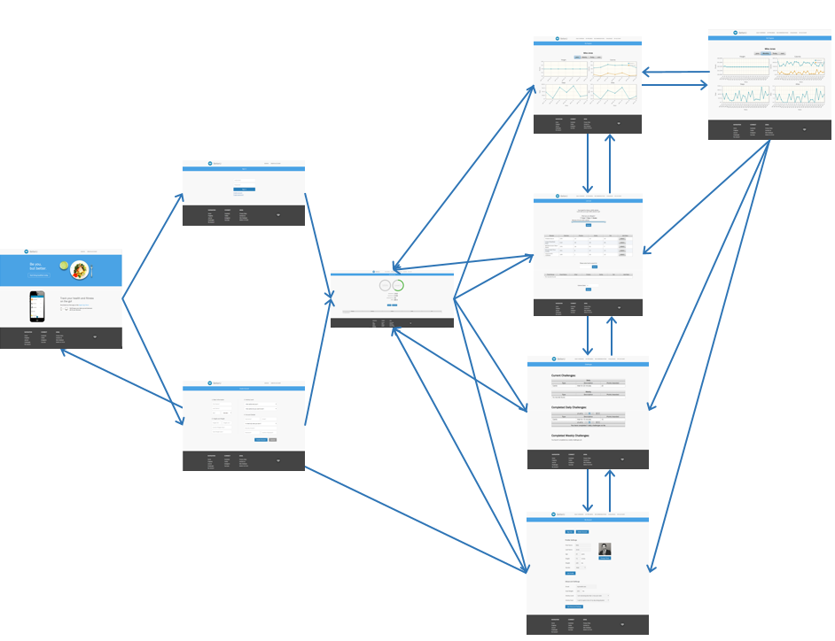

# DELIVERED SOFTWARE FUNCTIONALITY

## BetterU iOS Application

|  |  |
| --- | --- |
| https://lh3.googleusercontent.com/1IjsGX8kbwE7JF-rkgL8rYtD278xPnmxufLBIeFckY2vJokSC2TEGBotCIbE7b6TksYZ6Mv0TS6CqL3lzOgWxmSswD3VYZv9xYaA0vIEM9iRulX0W0kRJWTkwkrg4GtY1dOsA9sb | 1. From initial launch the start page the user clicks the”Let’s Get Started” button to be directed to the login page. |

|  |  |
| --- | --- |
| **https://lh4.googleusercontent.com/YVNzDCaTo4GxcoQLbuFaL60kOXMsu1-Yk85Zkv39qFt6GYReT4bXJgxMvzjnUBNBqIfj-uEEfG4TO-UZbUYwuH15iGQ66XJO6BcyP_-Uo7IpfstfJjOtygyogNt9I-96h9508821** | 1. The login form has two fields the first for the user’s name and the second field is for the user’s password. 2. There are also two buttons, the first button labeled “Log in” is to log in with the given username and password the second button is to create an account this button is labeled “Sign Up”. 3. The next set of pictures are going through the process to create an account. |

|  |  |
| --- | --- |
| **https://lh4.googleusercontent.com/8LiMNiVzwpUKaOCQvcXlJB8Xc13JCCknTussr_1A39bSeKg31hjL9HOWP7urQq12X7Fd_DFYGD5rycL7LoO1b1V_jH1yA8DsxXii0UzFckfbWg2tT1wARhf3oIvfbUEnSw9LFJCI** | 1. This window is the “Age and Gender” window in creating the user’s account. 2. This is where the user begins to enter their information for their account or the user may hit the back button in the top left of the window to go back to the “Log In” page. 3. There are four fields in this window from top to bottom the first is to enter the user’s first name. 4. The next field is to enter the user’s last name. 5. The third is to set the age of the user and the fourth is to choose the gender of user for this the user must click the appropriate picture. |

|  |  |
| --- | --- |
| **https://lh4.googleusercontent.com/DQcdhg8HoXVhNRwPYFe1Ssf71rMhIB4qXprMKz1cWBtEx66HW0E2ckGnwl4rM2d1RmNcKArK9xPFBuwVDoqregpPtRQ2Osf6gB55sVT6IPJgTah_hZUN_6PBXdrWN1sT5o4-PcNk** | 1. The third field in the window above for “Age” is a picker view slider that allows the user to scroll to their appropriate age. |

|  |  |
| --- | --- |
| **https://lh5.googleusercontent.com/JvnVoBLsErJAdvL4E0sYKskWuwpt1JbupWm-5-Pj9XEK-kyEhmj9ehhGmhVwGkQHHo-ixcBYWsuYrw2JKGf7jAJ4szyGPTHp-2ad2UdDOSS-th4maJoSbN7aguWfhQ-33PgL2vpV** | 1. Should the user not input all the fields there is form validation that alerts the user via an alert that there are missing entries. 2. This message will repeat as often as the user fails to enter all of the required information. |

|  |  |
| --- | --- |
| **https://lh6.googleusercontent.com/_7deBbEQ65molORZkREbOJwgQzcUsKjnn4wOiZUHMg60mYapJAs2itelo7YBHBTiyeRjpgU_4fvEbY8wS0cowNmA_Xz4-K5lHexLSmIfnIkmlaJZyct8frhIhVKdfZPOyUBCqn2M** | 1. Should the user enter all of the information required in the “Age and Gender” section they are directed to the “Height and Weight” window. 2. The user must enter in their height current weight and goal weight. 3. The User has the option to go back and edit the age and gender section by tapping the top left |

|  |  |
| --- | --- |
| **https://lh6.googleusercontent.com/1mAj8k9RZ5Ym83qmNrrHEbqBOeDk_952J1JLHn66atA-awoP-7VtEpyBZK9eRFdwISFwbMAo7ueuuela4j0-NUcu2l1VpLjb9xjrmTfCYNSHT-fwRkaLjKeK88r--tbUuMair7O4** | 1. The height field is a “UI Picker View” thus when the user clicks the field the picker view pops opens and the user chooses the most appropriate height. The current weight is a field that the user must input a number in. The goal weight field must also be a number that the user inputs. |

|  |  |
| --- | --- |
| **https://lh4.googleusercontent.com/Y6TPJmlvtS8JUbgBNBvaeSD8Lz0BScCpjhxReZW7GAHI_CN0EYJgKpV_XixakSF6kEELEv_e6zg5tEgyp3J8BHMZ9uBB9Jvh7euaKGlVDAzl7fE5Ybi1xnQBkXQUTfe-3ao6dk0I** | 1. As before should the user not put all the information that is needed there will be a message that appears to notify the user that the information is incorrect or not filled out with an alert. |

|  |  |
| --- | --- |
| **https://lh5.googleusercontent.com/mKxx7FAY4Tk_CGgm41n0X3sWtOgaaY5TgKWDnVRLPCszRn8uxTzNcFWtUj-1NMD0MkbGZ68n1-Z-K-T5rb5JSSg7DUL05mMpuvvlGRgnBm1jxKNaHlxvu3ldEuVxeSKLofyWiXbf** | 1. Should the information in the previous be filled out correctly the user is taken to the Activity Level form. 2. There are two options the user picks: the current activity level and the desired activity level. 3. Once the user selects the options a checkmark will appear and the row will be highlighted gray. 4. Once the user selects the options then the submit button can be pressed to proceed. 5. The user can go back to the previous height and weight |

|  |  |
| --- | --- |
| **https://lh4.googleusercontent.com/voEQ6VQv2bLy3Bf5RtdlkyQWTvfMzo3yo_VXTP3OIiJ2leW8NRauGhG8n-VBPRG6hRQqBvs9b67CuqlHkisQe_l56AmN36tUabwpqZmZ2UgqRLoCv5szrbb80c_onAmnE3acn7fc** | 1. If the user forgets to select one of the two options then an alert appears to notify them. 2. This repeats as many times until the user correctly chooses an option in both entries |

|  |  |
| --- | --- |
| **https://lh5.googleusercontent.com/4oGLQPuzOGncB-woYNrFl8vrES9htZd15jGxV0ONUlw796pIRpwZa9Ft_trczlixhz5IO5lE7Q2qDWLISQthCmjIFo04nAGRLBi1ZR8jtzzgDuYsnJUe5vcoMSyHG8QU5Qbs1Tk5** | 1. The final part of user creation appears on this view where the user enters in the account details. 2. The required entries are specified in the text boxes. 3. The security question will show a picker view with options of questions. 4. When the user enters in a password option, it will be a secret input with dots so it is not truly visible. 5. Once done the user can submit by pressing the submit button. |

|  |  |
| --- | --- |
| **https://lh4.googleusercontent.com/ASfrRQS7TN8vNL6PaAu2KgaFPqAmUEgtNBpt3OgIJgJ9V0jxqfZQRtZALSuUugU33KJScqFLOEk9oZalwkSTKaa6WSvS_djMUCeY8Pwmfz_7UKYXYwdSRz1cGkeTs1hP36PVm-PH** | 1. If the user misses a field and tries to submit then an alert with the corresponding property will pop up. 2. This will continue to show until the user correctly fills out all required fields. |

|  |  |
| --- | --- |
| **https://lh3.googleusercontent.com/3gYs3ViE4KN9ODwYN0yOqX8PwmcB4W16T25tTlh3eufVCUiDAqeeF4dmWYm8DcoQgxZ6cFHkRF-F7yzbyqZ4xUaz8maonxjo9f2UunPtmASvmgW_OcaTIJrcQSbRh0sjPLehR0S1** | 1. If the password and confirm password are incorrect then an alert will appear to let the user know. 2. Another alert will appear if the password does not meet requirements. |

|  |  |
| --- | --- |
| **https://lh3.googleusercontent.com/qNg4QroADGaTuz2opGCY9zrLsu3V5TUz54fdHlRzH2zdWcE_nTPzlLApKDoJ3ehk04mKxvtoQnGdmklj4tcZahP8gL769P2OFNKJp5SKaYs5O-ioybKFHB2w7xK7mbPOpfUskN9N** | 1. If the account was created successfully then the initial view with the log in will appear, allowing the user to log in to BetterU. |

|  |  |
| --- | --- |
| **https://lh6.googleusercontent.com/iVgqdLVCeP6TB2DbBEMA32GIzUcn98vaGAvv7McZ37s9w5JPsq4zAEQ9N8q10m-39ilgsWr2FCpImXwsR2AI9bgpg5HYbcxToe-EVSJucI-cuLm32WO916L8zrPpqPMi1yjcTn27** | 1. Upon successful log in the user is now directed to the home screen, which is a table view of all “health stats” 2. The topics of each row in the table view explain the what statistic can see as well as what the user daily overview is for the day. |

|  |  |
| --- | --- |
| **https://lh3.googleusercontent.com/kweKESk29JDV0dUj70fosZ0wI5qQmVgOMwe8aFWz8wjgabPCQeELOu8l4u2eMxRHL9NXk6t57R-04p_BazJxZeGKLf2ETDpbIvlLTJw3Pqrdgaz67eKQZ0qg7rArxzC3x4m7Hwty** | 1. Upon clicking the “Calories Burned” row in the previous screen the user is directed to this view. 2. This view contains the User’s records of calories burned. 3. This view contains a segmented control of the time range, a graph of the user’s history of calories burned, and a table view of the calories burned per hour in the past seven days. |

|  |  |
| --- | --- |
| **https://lh4.googleusercontent.com/j7qXUkZKZkTq9jL_9UnI_zZXeVcn17Pqjwi0Nd-O4ESM-zEsu6WVKlk94EUADDXoNAYA2mgBzSD38VcS_zxB6CbZddpC6ZB9HBvBDrPXnteL_SGU1NlEBxJH12EzShslKWCSZl1H** | 1. If the user taps on the “Week” of the segmented view then the page updates to show the week stats of calories burn. 2. It is the same layout of calories burned for days, but show the week. 3. The information is being pulled from the database when the user logs in all calories burned from the journal section of the application. |

|  |  |
| --- | --- |
| **https://lh6.googleusercontent.com/XjF4-BK35rRDTSGCcntIOAtWKj0vyrBIQHU4Pbd3X_BSF4PxChVzKOnf0ji8nBynLdmij8-jEYqpZxr5VRI52uy1GpRY78rZAkJh3L0M0x_Ib2M4wSYdtDKWp18JKxFuPdjYuj_3** | 1. The same applies to the month section of segmented view. 2. The table view gets updated to show calories burned this current week and the line graph updates to the four weeks of the current month. |

|  |  |
| --- | --- |
| **https://lh5.googleusercontent.com/9tt1DgCVLlIOAer-nQLhWD78cGqvtxTduSuSFTkyJ0SrAcZqytVla69vGhvlRKMLO-xwFirmyiiUQoQuE6NnZ_isgLKyEMeNjOzsH25g8qzcxdUWfWYkYfkVjA4E0Di6Gsp2-vqp** | 1. If the user taps on the line graph then, a line of where they tapped on the graph with the calorie amount of information displays on top. 2. If the user slides on the graph the line will follow and update the calorie information on top as well. This also applies to the day and month view. 3. The table view also slides vertically to show the previous weeks as well. The previous two segmented types does the same for their respective information. |

|  |  |
| --- | --- |
| **https://lh3.googleusercontent.com/ZKF-xBJuEqtcgnd0Sx_6Nw0-zF5vxjGJ3JendGf82KUZrcgO4RT_r_9IcbTgWJaeknKYVgRTj0d28uXPQNCIrn9bJVGXBSQ7UtXFNyjg9PIMwK8NHFEDDdrHBEAbdMTnHh9SiHer** | 1. When the user taps on Steps Taken from the initial home tab, they are taken to this view. 2. The view follows the same structure as the Calories Burned with all features being included as described in the pages before. |

|  |  |
| --- | --- |
| **https://lh4.googleusercontent.com/kiwqpGskrTaczXJTU7EKIXmq8Ld5mCxqWJDPp0Ucp0uOYcB451HXyKPHXtHhQKB2YzvpFqpDV9hdqUBsnWGA9NskznemQ2COQo8IgRo31YDWI8RtHp72uPuRrjZvHfqtRDe8NvwN** | 1. When the user taps on Miles Walked from the initial home tab, they are taken to this view. 2. The view follows the same structure as the Calories Burned with all features again described prior to this section. |

|  |  |
| --- | --- |
| **https://lh3.googleusercontent.com/Ock16dhMrnv1TB8IgIuqwnBTvBIuBSQryzc7FD80xw41Up0n4_3uw_-OPSf06yEZkOFRHZZ2jrX4ebRJd71sGLgizKuEPLkIa1wLShHMUaInR1L_IrG6ZIqL0bBVOrrQi0BqOHwP** | 1. When the user taps on Weight from the initial home tab, they are taken to this view. 2. The view follows the same structure as the Calories Burned with all features similar to it. 3. The Difference in this view that the other two is that there are only a week and month segmented view and a progress bar that shows how close the user is to the goal weight. |

|  |  |
| --- | --- |
| **https://lh3.googleusercontent.com/E_Tj3iLBQahW7dhV0ApMjma0aoM-GCpWsnqAB7WyqnsqC6HJV0E1M7YHXJKIVoUWzJEW-89sx08UF3F4cfaeX73Sn_Pk-O-dhPuoy1gLboNr78BOc-Q-S75fqUzHGyLFnf1Rcrbr** | 1. This is the view of the Caloric Intake Graph, which can be seen by tapping on its respective table cell in the home tab. 2. It follows the the same structure as the other home table view cells, but has two lines to show calories in vs. calories out. 3. There is also a progress circle that displays the user’s net calories over their recommended calories. It will be green if they are under their goal calories and red if they are over. It will reset on the new time cycle selected on the segmented view. |

|  |  |
| --- | --- |
| **https://lh4.googleusercontent.com/_z9QFQ2-d0GUbZfnGMUzhbBvZbz7cLqUlxtftJKVo6tGylIDxrZbz62rVOqCklpAIeC8XP5plQygv7l0cmIAcyWlGDKHNvxJUrJ47CdtyaSqe2nUWgye_Fi83VAbI43Qgerstuvn** | 1. Tapping on the my journal tab will come to this view. 2. Here the user can log calories via a manual number on the Log Calories Button or Getting a meal via the Recommend Me button. 3. The user can also log exercises tapping the Exercise on the segmented view. |

|  |  |
| --- | --- |
| **https://lh5.googleusercontent.com/OKuTdAdcO4K-_J2JvFWzK1OeGXlVeVAlzqfDr-ZTYURc1Ww8HNHPW1OsO814CrdUMLoMjpx7HZWD7CMGXJ1vAKqrQbz_kJjEpY_Ws6Ac9IuOuJKYi-f8_7eRmM6awyu-net4Ge7v** | 1. Tapping the log calories button on the previous screen brings you to this screen. 2. The User has the option to enter a actual number of calories via a textbox, using the barcode image icon on the top left, or using a food item search. |

|  |  |
| --- | --- |
| **https://lh4.googleusercontent.com/_EV065fQBe3Yc-H7uobhWsapcnZl10aMj9jUzkY6KRjMkU-sXBr9bgSU_s-ToUTKjN0tRLzzpcJBc-d_ESZJXWqaDXgc4g_PS7bBG-JjEG7hbkcXwt2R_b3GxQ7GDeLuQaia2gDX** | 1. Tapping the text box at the top will allow the user to enter the calories via the number if the user knows the exact amount. 2. Tapping the log calories with a number in the text box will log the calories and update the app and database accordingly. |

|  |  |
| --- | --- |
| **https://lh3.googleusercontent.com/aHfnKXg1c0zOmT2umXVsF7ad14W9VSS8ofp2tDCLP-BbCc3WvmI3vValQId1pPEuOquHPxeidXOq6qQhoSaPs-ZPkpWzNf3vMvymsT48JQto0Jc8wtPa7pohF9oYDTHuneT8_H9m** | 1. Entering in a valid food item will populate a table of search results from the USDA API. |

|  |  |
| --- | --- |
| **https://lh4.googleusercontent.com/_Traon9zQ9ROZ6B5106lnH0I3CuOh6MgWfkKeF_jf-HMYweWi66N0E_H3EJd1gJyzmIsgVkJpbS8DL4FXZWkWn89H18uBsmE2dspP1she-Q-hV6-qUhCvobX-s2HDkn3PqBdDOMm** | 1. Tapping on a row from the table view from the previous screen will show the nutrition facts of the item of that row. 2. Tapping on the serving size will bring up a “picker view” that give the user options of the serving size based on the USDA results. |

|  |  |
| --- | --- |
| **https://lh4.googleusercontent.com/rRF9XeyXg36Mrke0AhcbMo4AzzTE3F4IH8q86KLmrT8tyEhMErw1qE7EneRrIYsUrJEPpyf7CEIrI-bzG-MLAd1-jZKk2rXxT-gZxhrEi8wvmQQf-tqooBbNjpo40t_lqGEWYgP-** | 1. Tapping the Number of servings will allow the user to enter the servings they had of that option. 2. The edit of this information will update the nutrition facts accordingly. 3. Clicking the checkmark on the top right will allow the user to log the calories based off the serving size and number of servings. |

|  |  |
| --- | --- |
| **https://lh4.googleusercontent.com/WvoBxEgNVyQNOVDhPLwdLOsZEtpbyiGtdyx-GT9ywAbz3zDteupyweYfnVe-WDSMESmPd7o2h37JqnzZxNM8NMIJ1gvDvXJKnrrtMU4nZxI08Wds_4WnGAleyt3rT7CDdGb1oN3Y** | 1. Tapping the barcode icon from the initial log calories view will allow the user to scan a barcode of the item with the devices camera. 2. The user can scan a barcode by lining up the red line with the barcode. |

|  |  |
| --- | --- |
| **https://lh4.googleusercontent.com/uO-wq1Oi-BREVfzXe_VHMP3oe31p9DrMmqZh1VslAafOg1p3EvE-DNvci247n5Jpxp7ltVuuvTbThLn3HXfAj9PJ2Fyhee51wcC_oNsi1HmCphzASdrvq9Vjf0-96AH48mzBOf6i** | 1. As shown the barcode reader display a red band that the user is then to line up with the barcode as shown to the left. 2. Upon successfully scanning said barcode the user is then redirected to the nutritional information about the item in question as shown in the next page. |

|  |  |
| --- | --- |
| **https://lh4.googleusercontent.com/tWm-DsfydUXfg00TU5F0cR5Cu5u114hQ7yTS9HEjk7xsMqUUSVbibaci2XXbBcNY71_HKTqWl0EWwJKTtsi8rvOAJ9pp3WKu7PGOuPF3BgSND6CROLHHMF6sVP5dY7TM-ny9fDVd** | 1. As mentioned from the previous view the user is navigated to this view after scanning a valid barcode. 2. The  Nutritionix API is then called with the information from the barcode and then the information is populated as can be seen in the picture to the left. 3. The user is also able to edit the serving size depending upon how much the user intaked. The nutritional information will be updated as the user edits the serving size. 4. The user is also able to edit the the number of servings should the user intake more than a single serving. Again once this information is edited the nutritional information is updated accordingly. |

|  |  |
| --- | --- |
| **https://lh6.googleusercontent.com/foU8UQuC5LBi9LpsIG8_FWRMk0tEDUeLs2Pj0qpzIeAeGDYZx-YEsJmFk3hBlbnK2pl0bWRxTiwJAJgg3EnQB3ZPd6damszoMSl9Ta-9OCtjSOr22EIl7e8BZnEsVVgS9vloS-hu** | 1. The user can simply log in calories if they know the the number if they looked it up manually. |

|  |  |
| --- | --- |
| **https://lh4.googleusercontent.com/LZqp7KkHwAOUg6pFLNXxiwCF2XMjojZ0abQPvhIBgfZ1hgNXvz2BeLlcM8zruQMsZNJKrIrxjnMXNS0gZ8r1S5Xth_VFIprTFRpVSyLiCCL0Fgt2nVdRPbW9hhehK0Z0JJOoCttH** | 1. Pressing the log calories button will take the user back to the home screen with the updated caloric intake information. |

|  |  |
| --- | --- |
| **https://lh4.googleusercontent.com/53U-Gkj67X91tS4NJPWEfmCwYHY8186xwALyudiKPrZHflgVbACUp94EbN9yklOq7Nm_RQafLFEzddN_4H7oEUkXTLaJWYkrOL8MORJUP_xf3Jfaj59hJx1vMYMrRaTmyBKLTPj1** | 1. This window has tableview with different colors (as color coding the caloric range) and a text input field. 2. The text field is so the user can input any allergens or disliked foods multiple entries are delimited by commas. 3. The table view shows the user based on color the types of meals they can choose from (light meals -> very heavy meals). The caloric amounts is also displayed on each entry. |

|  |  |
| --- | --- |
| **https://lh5.googleusercontent.com/gtJUfiB72ruJ8guxCv_rrutZ88-hCV5AyXXiGu4vVK_FEIPZWYPIhFvvcjVkdduz8dIvzFzKFhvrPMSxyCp-brSdeeD28iqK5myEdvEUjy5h4cdnB9Fa7S2i3a3ciHh_oMgTOXkL** | 1. Upon clicking one of the colored rows in the previous fields the user is brought to a loading screen populating the recommendation list from the Yummly API. |

|  |  |
| --- | --- |
|  |  |

|  |  |
| --- | --- |
| **https://lh6.googleusercontent.com/vBPEER4X8-yrribyMHmwLARz01Ya-bbsNKK19mwZaOJL-aD1PvI4G9OxOZ4fB_2gA1hxmN_obL3sXkR6yZGiitdB_78L2kMQBMVaDjr0NY95LW30uK5v1TqbvnqUVoMl-9GHoQ0a** | 1. This view contains all of the recipes that match the user’s preferences (caloric requirements, filtering allergens or dislikes) from the Yummly API. 2. Each recipe that is displayed show a rating and the name of the said food along with a picture in a table view. 3. Upon choosing a recipe via tapping the wanted food entry the user is then brought to the details page of said recipe as described in the next view. |

|  |  |
| --- | --- |
|  |  |

|  |  |
| --- | --- |
| **https://lh3.googleusercontent.com/smc1pEqGOXiUWK0zZyz6txiODjBexX56hO7PUSZIftCOLXhwL3DwNd0mxqpBDH4AamY6y3K9I38IXBRng9CqMA3Gs8zZ9s5y3HWPy7rY3TSd30jWnQ50fM7oId60R7fp7xGEnv3G** | 1. This window is the details page of the recipe as described in the previous page. 2. This window displays a picture of the recipe. 3. The nutritional information of the recipe is also displayed. 4. Finally there is a link to the webview that contains all of the directions for the recipe. This link is in the form of a button labeled “Get Recipe”. 5. Once the user taps the “Get Recipe” button the user will then be navigated to the web view for the recipe as described in the next page. |

|  |  |
| --- | --- |
|  |  |

|  |  |
| --- | --- |
| **https://lh3.googleusercontent.com/_DBbYercj1pJKpzSz0N69xgGcD6xyDLIZkX5qbUDnloMp4S3DOGNx88sF9EnzLk3p6tDUesRNI6g8G6-I2xIZrcdTMyUsBCfOnT5lXqOL0IlPUZ40uQbXRQ3Od4r5g3tKlDeQDAR** | 1. This web page is for the recipe as described from the previous page when the user taps on the entry. 2. This web page goes into detail on how to make the recipe as chosen from the previous window. 3. Should the user choose this recipe for their meal they can then select the time slot for the meal (e.g. breakfast, lunch,dinner,etc). 4. The next page shows this process of selecting the meal slots. |

|  |  |
| --- | --- |
| **https://lh6.googleusercontent.com/32gYws-DK9rAqVi_wk2tEGmiDb0PdCYRhw57ZOcqxUST30s3Tw-eQUb8YW3tf9xS0xd7ncf9HDVUtepYgnQ3gF92mtnh_ldZkl9MQggInzpx82U0GkA_MawPTZ7DF3jiwwXKGqF_** | 1. Tapping the Get Recipe button will allow the user to make this recipe in their daily meal schedule.(Breakfast,Lunch,Dinner,etc) |

|  |  |
| --- | --- |
| **https://lh3.googleusercontent.com/qwNWFJfXUNfeLf4cPysPCsQ27oTHL13Q000Bs8Zukt2-1yVX1yiHVFc-P9jTn0wYbgVOmm6OY51UZ1TaV5hYapYBdykUtxUlHRgnjvhASPFR3N3DOUJDH3gewa3CUR3BA9DjeCA_** | 1. The meal is then added to the main journal screen under the specified meal time it was eaten. The calories are logged and put into the database. |

|  |  |
| --- | --- |
|  |  |

|  |  |
| --- | --- |
| **https://lh4.googleusercontent.com/lGEPBE9Jvdj7MnXMnYmKJGX2N1tFLHVmoo9TmjLi-AAZkLz6eD1dH4uqVPbNll2ek-T4mp68mFbkjAMod48TPh0AI48VWfOP5GRl2jppaxrWKgILn2NroB_rBpR2AqkGfTfblcuq** | 1. If the user decides that the food item is in the wrong section or does not want it in the log anymore they can move it between meal times or delete it. |

|  |  |
| --- | --- |
| **https://lh4.googleusercontent.com/UeoWDLEJJ4Lo-TrfMOYY0gP4ianBNhjHUhuQffwtnVRfbHtDHy0thGDL0qDH2f3Lmyz1F_N8zZhPXRKGiiRIZhhsWWTZDPhrPf1s-SZyUnL02Y7qofYJspGHtc79fl6c9W86OQel** | 1. Tapping the Exercise segment of the segmented control brings the user to this view in the application 2. Here the user can log exercises manually or get recommendations. 3. There is also a table view showing the user their workouts and recommended workouts entries |

|  |  |
| --- | --- |
| **https://lh5.googleusercontent.com/gQFF4onCiWELBF0L7_sQYnSOj4XjdpnSkaeZLgE3v4y_r-CxG7t6Wt6b8UbgHFy9P5_5kV8Yc6zXVE9qse8LPHkmWw9P9u9KKvrqRHW8um8vxReC5PB2TjeRJ2-Y4fDDfgFhCgez** | 1. From the Log Exercise page, users can enter a description of their exercise and the length of their workout in minutes. 2. Entering the number of reps per set, number of reps, and weight per set is optional but it helps make the information more accurate. 3. Finally, the User must choose an intensity level for their workout on the sliding button. 4. Intensity level information is color coordinated on the help graphic at the bottom of the screen. |

|  |  |
| --- | --- |
| **https://lh6.googleusercontent.com/XGMTiOOCA7VP5wJbTZcjV0n39d_NZ21vdI44nwKCLaNFKSaR7I4TxrT54cXGzkt5WkOHvnTELb8Kg7Y1tPVgFAbIjGaJMJ8j8A-0xYnOgFaoJ184XHfNFjVAHqDe6Q8tLoNn7lO6** | 1. Once the user enters the required exercise information, it calculates how many calories were burned during your workout. |

|  |  |
| --- | --- |
| **https://lh3.googleusercontent.com/ZtcTBMZQNjJuh3GYTva0IHoXFRqoZfjXZbllayCafpMUxHmNxTstylsfsghAL0rbW7Kh57Bca44qOc5DNZ_BPeFwtYgDCcRXf5ax6wOjmFU7FF8LSvEfd_uOPLwvV5DHTwmeKP_L** | 1. This window shows the user their basic overlay of the exercises they have logged in their account. 2. Within each of these entries the number of reps(if applicable), the weight(if applicable), the time(required), and intensity are recorded. 3. The user also has the ability of looking up recommended exercises. To do this the users can hit the “Recommend Me” button and be brought to exercise recommendations section as shown in the next page. |

|  |  |
| --- | --- |
| **https://lh4.googleusercontent.com/KXRQ54igbRsE6p6XPoMhyT2hJ5wHK4AwihFrtfiCgTPFZ-CYMvM-61Ba_SbPAUcpPL1aQ6NnUHQ9PXFXcKz3RzQsHrgVnapJosc_Y6U0XP7o4VO4U500acxtGLjQ6qvcn2-dgXTN** | 1. If the user hits the recommend me button they are brought to this page. Here the user can select a muscle group that they want to work out. |

|  |  |
| --- | --- |
| **https://lh5.googleusercontent.com/FCMDVgAUY-6a1VW5sPBUe2fiQ8f84OwNrEdZVqaQcN22SgWwnP3-1uejl42DRVorFAq9DUa553AjFPzgjcvcBTdYoc3qCweyB3TaTTJcHeGNwq1c3mt4krKbayq72LzI160eMbM1** | 1. If they select a certain muscle group they can pull down to reveal the exercises specific to that muscle group with information from the WGER API. |

|  |  |
| --- | --- |
| **https://lh4.googleusercontent.com/XcbFOvK7jK_BLol_JeMw3_WstSWeDJaGODHrCToPdbkqdMfamQydxL_8mdlI6ONSAWoG-VbmPqhb6JYcgimybI_pBDhouirq_StpIEkUZlN7XAOrj6XggXFEdHdxKLgC1mMvyfTl** | 1. This is the populated table after the user has pulled down to fetch for data via the WGER API. In this example these are all the exercises that targets the abs. |

|  |  |
| --- | --- |
| **https://lh3.googleusercontent.com/6UdkIJX5O_W9jrwTcko4ZzO_38riJ1CQob3Rk4aGm78NWNEzc8oWlSc8FfnXMjOC9MUsLmQW4HfnNf9EZiYsbI_72vBKblB3e_X47ZHcnbCfoLpSDQ6AXPlFTUpKZaoqPp-gFehH** | 1. They can select an exercise for more information. The instructions are presented by the very first image tab. |

|  |  |
| --- | --- |
| **https://lh3.googleusercontent.com/mM02prZm3RISZ-f8X2rUmmRcKUCic8taOeRVe2wC6mg2RmmKaja6ZhSarZimsT81aoVXDHdGCnpJKRbsBLGMFfzSw8zpyRbuo6vEW6rl2rPkPCdLSqxwSO0buyrZ6IWZ0YYW7778** | 1. This window allows the user to view the workout stepwise in picture form. 2. This only applies should the WGER API actually have a picture demonstration of the workout. 3. The user can also hit the next tab to have a picture of which muscle groups are worked as described in the next picture. 4. There may be no image of the workout which will notify the user if the api has no information on it. |

|  |  |
| --- | --- |
| **https://lh5.googleusercontent.com/Ua7GqQF4lT9SVpqAYEMx57WR6ytBSTQuE9_yFD3Remza_Bu7WDQ-ufltwTg0KgZIC9N06KU8xsQXAlfGSpVE_qlMV4fmMnDQKY_C7J8RBQu_4OzxzGyL3Whs6ERAniSyLTfnt-r7** | 1. The third image tab reveals the muscles groups that this specific exercise targets. 2. The proper names of said muscle groups are also displayed so that the user can then learn more about the body in addition to just the workout routine. |

|  |  |
| --- | --- |
| **https://lh6.googleusercontent.com/gtyJLXH_UW805LmT8HH0eXuM1CIRlMUYOz2-nAhQcktJ32cXPQQ6NC_e-n4gIi58NBZWeM4qN3q7mFihsrMQcRrfGPbRBa-3FUfO9mlKPcfHA48RQu3JEKJAlicvP73S-EvYp9YS** | 1. They can then add the exercise to their recommended exercises group. 2. Should the user not want to have this exercise  or a logged exercise in their journal they can delete the entry as described in the next page. |

|  |  |
| --- | --- |
| **https://lh3.googleusercontent.com/B0G7PMABKtONeE5GyXzcVqvhhNJl9QEOmgdDV6P3OMytKTNGUEo4sHXwZwHnp6C5ZblPhD2kuM-O_7MfwHnSgLCXjWi6tNNnprZTe8XJ4d_Kvx8jb5nVtugCeJvKhkH6EsN051mp** | 1. If the user decides that they no longer want an exercise in either category, they can select edit and remove that exercise from their list. If the user decides they no longer want an exercise in either category, the user can select edit and remove that exercise from their list. |

|  |  |
| --- | --- |
| **https://lh4.googleusercontent.com/p7XVJ61gOMhti5usDTcdx6HcOaVVkvrVK9oP8YAy_dxi6iayMxsxTUBe7zno6FmWryngtFLZNO-68QbZSnVDDe2jMgdZzmm1dbfOV76VcLiAQj5oRqNzAYIyXTvYwtSPPHp1rBZI** | 1. Tapping on the challenges tab in the tab bar will bring the user to this view. 2. Here the user can view current challenges they are taking on, daily and weekly challenges they can take on, and past challenges they completed. |

|  |  |
| --- | --- |
| **https://lh3.googleusercontent.com/5414-Mjy07TDfYQRJGf1NgBp3jsqoamFKC2LCwh8xy17AidDM2NHpciv8kcoXEJpnK3LqYmjOl4iMBwmPrAY1afoJu3WW73mk5W0izcIkVfiihDmsc0CyDN8jBuIL7dhejrhfxsl** | 1. The user can tap each section of the challenges page as described in the previous page to have each set of challenges expanded and details about each challenge displayed. 2. The challenges are set in current challenges that the user has accepted, daily challenges that are recommended to the user, and weekly challenges recommended to the user, finally there is a section that shows the user all of the previous challenges they have done. |

|  |  |
| --- | --- |
| **https://lh6.googleusercontent.com/biWtXtiXMJT4TC5PHwDl8jZyCqFyKEUvWb2ocQszl2FhDefN3iLTSaZABbUUhiuj4oS9RruJkH55W61wDVIf5SDMlqXDO1B4xZUJ4qZX7MxV-q0moqzKBNAAHmP-sxDwmpaH9Xpj** | 1. Should the user select a challenge that they have not already accepted they will be alerted by this pop up to verify that the user indeed wishes to accept this challenge. 2. Should the user tap cancel the challenge will stay in the the appropriate challenge section. |

|  |  |
| --- | --- |
| **https://lh4.googleusercontent.com/EqJq1EeZush-5Ly6Hzb3piOx6nZHVuhO62n4Y3emiKqnVuiqex3LDKbr-FF7oZMgWqaReB2i16GjOJpD1Kc70Kgv-U_juAvgSuhVWCRk00L5PrsXt1UTUuAAuYN-fLbcEk0wI3jp** | 1. Should the user chose to accept a challenge the challenge will move from the section of challenges that it was and then will be moved to the current challenges. 2. This example from the previous page showed “Do 3 sets of 10 crunches” that moved from the “Daily Challenges” to the “Current Challenges” section. |

|  |  |
| --- | --- |
| **https://lh5.googleusercontent.com/twZAYJje6C9v6-9qnbQohM7emIMkBJLHFyiykYTxpOBlzQP1CLN7ex4k0Tkb8AG1ad-SeTFEMauuW_qgYmECwdbMWMGAqCGA2Re1pK-xo7Oh9I5QROdNXBOdq1pyeTERb9ZpyAyD** | 1. Should the user wish to set a challenge as completed or to remove a challenge from their current challenges this window will appear should the user tap the challenge within the “Current Challenge” section. 2. Should the user select to remove the challenge the challenge will then be put back into it correct location that it was previously. 3. This example is again using the “Do 3 sets of 10 crunches” as shown in the next page. 4. This is based on a honor system of the user. |

|  |  |
| --- | --- |
| **https://lh3.googleusercontent.com/8mOFHAogAfkMsyQoOc6Ox-9udS0bLoBaRSmqXnEXJIn8MVRlRu2Zxq-DDf2yKzoPiJEu4yDQT17rR_sVMImj1Zz-cB1bju-QGJtcyv9deu9e34K79VByEZmuSLXkXz-qodiwHIrP** | 1. Should the user choose to complete a challenge as described in the previous picture the challenge will move from the current challenges to the past challenges section. 2. The challenge will then not be repeated and the points that would be awarded for the challenge will be added to the user’s account. |

|  |  |
| --- | --- |
| **https://lh5.googleusercontent.com/YX0P_eUV9-t9DgichuEJXa7jVntAgDLlVqi4Fz7gtRd_aQVSgNscAPKVCtVWALAFkwB9ktmKEf8IJ3DPFnuHaNxKdJq2Mpyv12IThNwawmYdzM2hwOrg_spnrwHM4yknuIX-x7hi** | 1. Should the user choose a weekly challenge they will be warned that the challenge that they wish to take is harder than other daily challenges. 2. The same process of the challenge being moved to the current challenges to from the “Weekly Challenges” is repeat as it would for a “Daily Challenge”. |

|  |  |
| --- | --- |
| **https://lh3.googleusercontent.com/JQasEw18Oc924vSTtXpWEUiPPgL-y22XxlJg6_hnDwWJf7xopa8udO06xgAGsV26vKrbAh_3fKZQHTJSlqwFqQj1wn-U2IPPPlYYXv46hh6oUMOGdE6cYLU65VmhHwstHfI30aiF** | 1. If the user accepts the weekly challenge then it will be moved to their current challenges. |

|  |  |
| --- | --- |
| **https://lh3.googleusercontent.com/IWfNchRFCqFwPNqC_XgLpiu4NweAAMlPC4k1t_W9ZalBKhc5pJdA3y6uY8EykCjyxOVVIK-rzHHIARXSooZl0t5D2Q2rmHos_BDt5XWqohTL2fKSrEST3lvVJJtjqRnVTXCHrbRC** | 1. If the user declines the weekly challenge or does not feel like completing it then it is moved back into the weekly section of the challenges tab. It will update to a new challenge in a week. |

|  |  |
| --- | --- |
| **https://lh3.googleusercontent.com/tSdlDUi5fFg6KZ88AFyyWlCohtJCrEhqhgTMq_rSvHzbtKwge8VoAo7tPudyFcw7Kt6GKLd3wY7xQk2xqvAtITfd0lW8sQ5sRbx7cop4miFml3vpCfgG0m4XQ19IJVzr0ijtSB1v** | 1. Upon completing challenges the user can view their “Level” on how many challenges they completed, the more challenges they complete the points they get and advance on. 2. The user has basic information about their account displayed on this page.  It shows their full name, email, and level. 3. Shortcuts to more advanced settings and contact information are shown on the bottom half of the screen. 4. The option to logout was provided on a button at the bottom of the screen. |

|  |  |
| --- | --- |
| **https://lh5.googleusercontent.com/U16bfA_NognJjKhkjHyF0cF7CDsz9AwgBk-ZZtM7Jrnj0lG1HtuytTv-LVn4jgMa9k7TJ7cg_oXnOWk0a24Gqt106-h7r8uYvi_H7_Rs3qJ3V4uy2Lamo4EM-kwUeM0T02BcY0ZK** | 1. The user can view/edit all their information on this page, as well as edit their basic information.  Basic information includes first and last name, age, height, weight, and gender. 2. Upon hitting the “Save” button the information is then updated to the database and the user will see the changes momentarily. |

|  |  |
| --- | --- |
| **https://lh6.googleusercontent.com/7ERS9VhFNLEYPVge1nev1Ffmk_P8O8h0TZeeDPycE6Ew2xRojwpNTTNSNG1xNOHMq1EwscM3a4TKX-OxfPaUy5hCD_Rtl-Z3p9B3ex7590C2RvS7UhgLMBnbzIQ3vQz8WEQnXGgg** | 1. The user can view/edit their advanced settings, including email, goal weight, password, and activity level. |

|  |  |
| --- | --- |
| **https://lh6.googleusercontent.com/rJ4G3gWNgpeKyKkrt4PT552xr1v3v7KJ5lJ6K6n-QaTdNND1Z0rgJkdhgxJqf9S_CHDkjP8Z0MZsCi74rNVrxC4SrddWHbJGPQ78bnu19hlQfRUDZQVI134idOW1hHV5b8PzF13I** | 1. In the top half of this screen, users can choose their current level of activity, whether that be sedentary, lightly active, active, or very active. 2. The bottom half of this screen allows the user to choose, from the same list of options, what level of activity they would like to achieve in the future. |

|  |  |
| --- | --- |
| **https://lh3.googleusercontent.com/_btdCamHSvjxBy06RjCGpZ1Ecw3sK07Ff7m2vsTqFPsWOVgy-i-Kv5yRYc49yCc_KVMKX1uQLXSG5eiNvV7SHQKfOuBykV1whM727DSsuhFy0m4s9eq4CNvAL21nbVZkJhcGuE0v** | 1. The Contact Information page displays the app logo, name, copyright, and version, as well as the sponsor and an email address at which the user can contact the developers. |

|  |  |
| --- | --- |
| **https://lh5.googleusercontent.com/geegtUzrbtK55r63DHtVJHUYPgCG6ZBjM6RIeDtFn4qBfIRRWfO7TEI8HnukymFeHvt4uptJki-XU5ghsJbrnlIN5zdTIW8q8TRjFloogPIunpx6gCbir2w881TEweW7cGM1Cdbb** | 1. From the exploding button, the user can find shortcuts to each of the following functionalities: Progress, Challenges, Calories, Exercise, Weight as described fully in the prior pages of the document. |

|  |  |
| --- | --- |
| **https://lh3.googleusercontent.com/eOOq9uYazl-V4q4I5_gyNcDL5r1pfwoxcUqmTUaU8T6W8Ubdgp5BiyI6gxpwEB4fbx1ZBMfBhRuH7enDxvWjup85uItVjp15vXzBGy_yjrnADY4-jeDEZn6b5dIIOzBeRn4LahAy** | 1. From the exploding button “Progress” button, users can easily access their progress information. 2. The user is brought to a mini table view where the user can access their stats like they can in the home page. |

|  |  |
| --- | --- |
| **https://lh5.googleusercontent.com/aBCfnOd3XnwygthS1RpOo7LfOeeRrIcsPntfjha7BdGfh3Ud8LvzNY4PMvd_UvHcYc9ZJ07B6uxzQRvVYCK4_yX_NIVKUxSkZBz8fZ76VvJUjfQmij5rykKwusMnMhLaA5InGnEg** | 1. From the exploding tab “Challenges” button, users can see their current challenges. 2. Clicking on the challenge will alert the user if they completed the challenge or not. |

|  |  |
| --- | --- |
| **https://lh5.googleusercontent.com/TNmoduItrBp4MHPCEYxanbvb48jTF2a0yHX7wFBHAVr5AYP950AZie7ySzPRsH1JFAp8H40f72aLbuwWdmxdY7xYww1za2D1Jz7w1SIEHbjpkgxZ7qg6sIw8EJg3q9H4mA3enMEY** | 1. From the exploding tab “Calories” button, users can easily enter their calories. 2. The database will automatically update the information, and the graphs will update accordingly upon hitting the “Submit” button. |

|  |  |
| --- | --- |
| **https://lh5.googleusercontent.com/RrpIiFjxrd5Mgjg-6pUIr8l1mR7Z6hdAmNZrJU5vL80Izaqzr7vdI7ORBBZSFh1zEWt9QXG606VHnMDZW99iZ2lb9vAiyEVC-6B-Cy_lacMrx4G_evxMMY0TV9We7Daotnuuu4ge** | 1. From the exploding button menu the Exercise option will take the user back to the log exercise view and the user can log the exercise and update the database accordingly. |

|  |  |
| --- | --- |
| **https://lh6.googleusercontent.com/Z1X9GU98b2ACp6we2T48xXTonqzDCzpkOKR_lpOLabAjh2eMuDfCTW-ddCnuDg52jZrku__QFn7xDQpNE3JrMb2_g5QFvBpnovIQqfiuomxF1OJnuv69fubXVSH3XpKTxT0_7hWJ** | 1. The exploding tab “Weight” button displays a weight scale in pounds. 2. Users can slide the scale left and right to adjust the weight, and the information will be updated in the database and on the users profile. |

## BetterU Web Application

To access, go to http://jupiter.cs.vt.edu/BetterU-Web

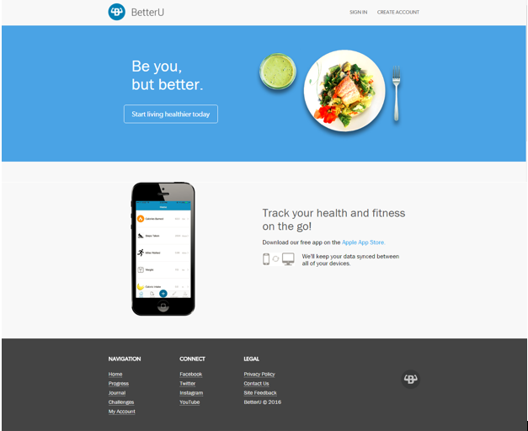

1. This is the main website page in the header there are two main buttons labeled Sign In and Create Account.
2. In the body there are two buttons  one is next button to be clicked is labeled “Start living healthier today” the next is a link that once clicked takes you to the apple store to download the app.
3. In the footer there are a number of links to the different pages of the website.
4. Under navigation: Home,Programs,Journal, Challenges, My Account.
5. Under Connect: Facebook, Twitter, Instagram, YouTube.
6. Under Legal: Privacy Policy, Contact Us, Site Feedback, then we have the logo.

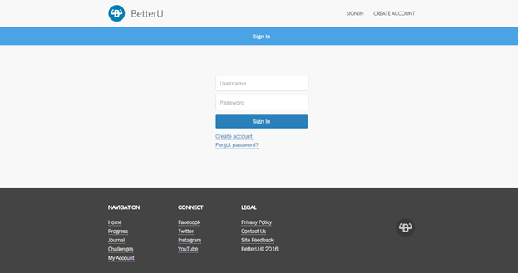

1. This window is the sign in page here in the body we have a form that asks for a username and password the “Sign In” button is to send the request to log in to the server.
2. Underneath the sign in button there are two links “Create Account” which redirects you to the create account page.
3. Underneath the “Create Account” link there is a link “Forgot Password”.

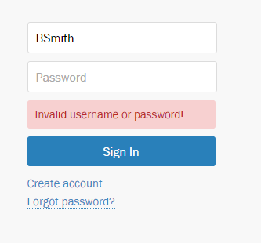

1. Above is an example of the username and password validation.

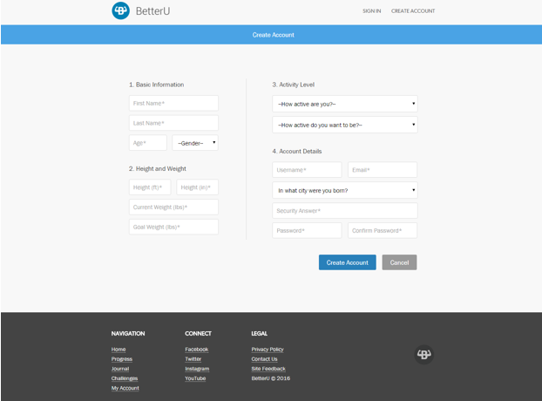

1. This is the “Create Account” page in it there are many fields that all are required.
2. For Basic Information the fields are: First Name, Last Name,Age,Gender (that is a drop down menu), Height (ft),Height(in), Current Weight, Goal Weight.
3. The activity level section has two drop downs, first is how active are you currently with the options of: I am exercising less than 1 hour per week, I am exercising less than 2-5 hours per week, I am exercising less than 5-7 hours per week, I am exercising less than 8+ hours per week.
4. The second section has similar options they are: I want to be  exercising  2-5 hours per week, I want to be  exercising  5-7 hours per week, I want to be  exercising  8+ hours per week, and I do not know.
5. Under the “Account Details” the fields are username, email,a security question field and a scroll bar with preset questions, also have a password and confirmation for the password.

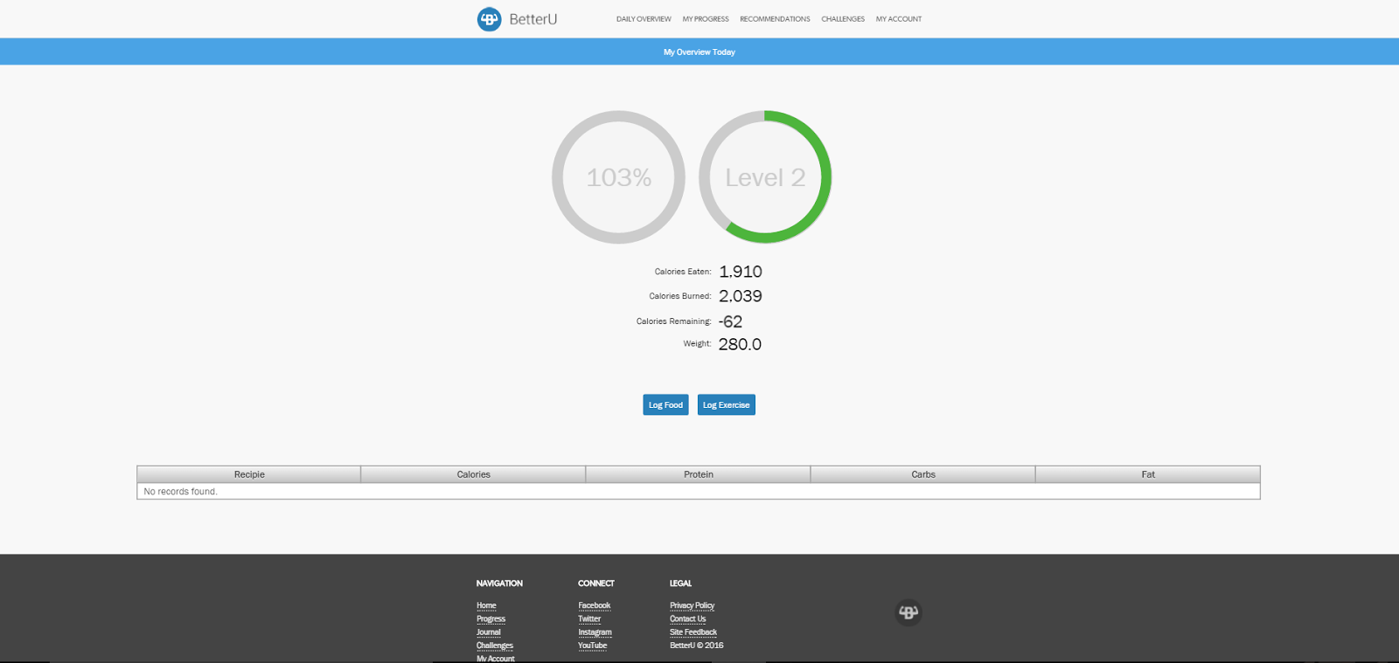

1. Upon entering correct login information or creating an account you are brought to the “Daily Progress” page.
2. The left wheel correlates to the daily caloric intake and the right wheel correlates to the users level according to our leveled system based on completed challenges.
3. Below the wheels there are a few fields that populate for each user based on their information they are: Calories eaten, Calories Burned, Calories remaining for the day, and Weight.

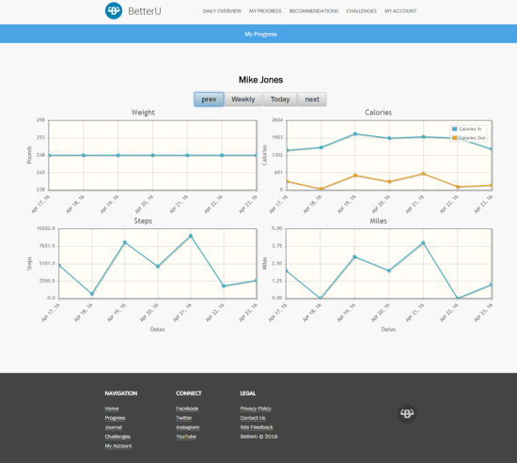

1. This web page is the “My Progress” page each of the graphs shown can be set for daily,weekly, monthly sections if the database has information of the users that dates back that long. The user can cycle between months with the prev and next buttons in the heading.
2. The graph on the top left is the users weight daily,weekly or monthly.
3. The graph on the top right is caloric intake and calories burned again daily, weekly,monthly.
4. The graph on the bottom left is the steps taken by the user daily,weekly, or monthly.
5. The graph on the bottom right is the miles travelled by the user daily,weekly,or monthly.

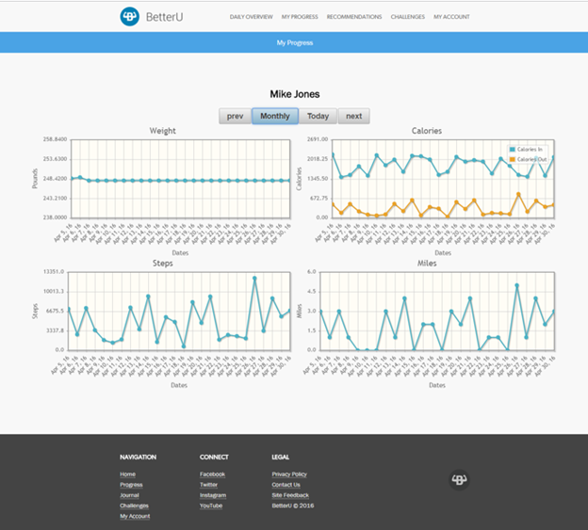

1. Above is another instance of the 4 graphs as discussed on the previous page yet the information is on the monthly cycle instance.

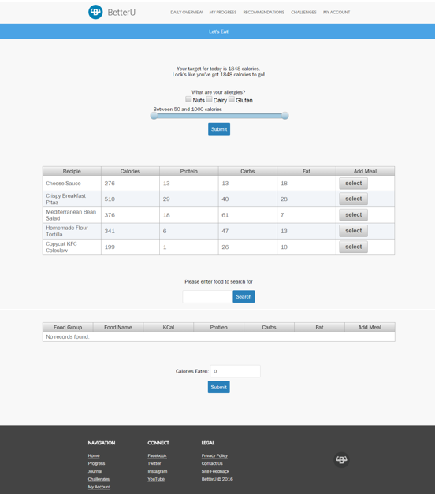

1. This is the “Recommendations tab” this page is broken into two sections.
2. The upper portion is the Yummly API call in it there are a few buttons that allow the user to mention common food allergies. The slider is to specify how many calories someone would want to put into a recipe. After choosing an amount of calories for the meal the datatable is then updated.
3. The lower portion is the USDA API where the text form takes the users request and searches the database and then populates the datatable as for the Yummly API section.

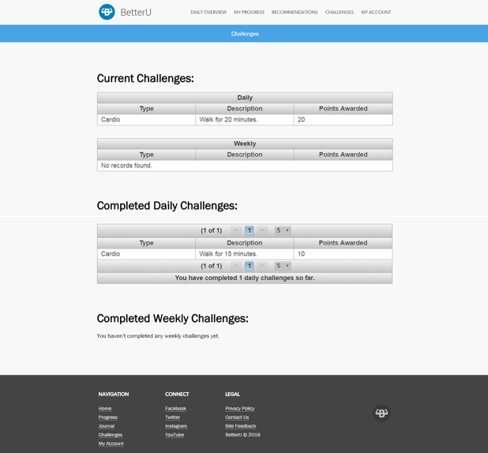

1. This is the ‘Challenges Webpage” this webpage is a supplement to the mobile application since the information that is populated in the three sections are polled from the mobile database.
2. From the top the first section is the “Current Challenges”  this section shows the users what challenges they have accepted and that are currently trying to be completed and the points associated with them.
3. The next section is the “Completed Challenges” in this section the user is able to view their completed challenges and view the points awarded.
4. The final section is the “Completed Challenges” section in which the user can view their completed challenges and the awarded points from said challenge.

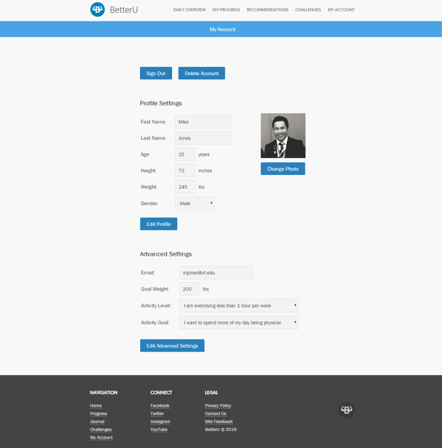

1. This is the “My Account” page there are many features in this web page most notable is that as opposed to the mobile application the user can change their picture should they desire. This web page is broken into two sections.
2. In the first section labeled “Public Settings” the user is able to edit their name(first,last), their age, their height(in inches), their weight(lbs), their gender(male,female).
3. In the last section labeled “Advanced Settings” the user is able to edit their email, goal weight, activity level , and activity goal. As when creating their account the activity level and goal have drop down menus with multiple options.

# CONCLUSIONS

The development of BetterU was very involved and very successful. The product we have created is useful, intuitive, and polished. It has filled a void in the mobile app market that desperately needed filling. A major challenge that we faced when developing BetterU was the timeline. The length of the problem specification, requirements, architecture, and design phases only left 6 weeks for development of a very complicated application. However, having a distinct vision of the product allowed for a more efficient and effective development of BetterU.

Given more time, BetterU would have loved to incorporate Facebook into BetterU to allow users to challenge their friends to add a competitive motivator to the product. We find that the competitive aspects of existing fitness applications are their most successful features and believe BetterU would be greatly improved with this feature.

The BetterU team did a great job of learning how to communicate with each other to build the application. It was difficult in the beginning to figure out how to best plan out and communicate about the implementation of features of the app, but over time figured out what questions we needed to ask in order to stay on the same page. In the end, communication was the most important aspect of developing the application. We are very excited about the final product that we have developed.

REFERENCES

Balci, O. (2016), “CS4984 Cloud Software Development Course Website,” <http://manta.cs.vt.edu/cs4984>

Oracle Corporation (2016), “NetBeans,” <https://netbeans.org/>

TEAM MEMBER CONTRIBUTIONS

Each team member provides a numbered list of his/her accomplishments in a concise and clear manner below.

|  |
| --- |
| Julia M. Binger |
| 1. Database design, implementation, and management. 2. Synchronized endpoints for weight between User and Progress DBs. 3. Worked on timer refresh to make new entries in the Progress DB every midnight. 4. Updated files to incorporate compound primary key for Progress. 5. Helped the team understand GitHub. 6. Worked on Problem and Architecture Specification in the report. 7. Created Architecture models 8. Wrote functions to calculate BMR and target calories 9. Wrote functions to grab a week or month of progress data based on current date and user 10. Managed synchronization across git branches 11. Re-deployed app on Jupiter as needed |
| Mykhaylo D. Bulgakov |
| 1. Assisted with initial database schema design and implementation. 2. Assisted with initial RESTful API implementation 3. Assisted with creation of requirements and design of features of BetterU during design phase. 4. Handled iOS and backend communications.    1. Implemented use of Alamofire and SwiftyJSON in order to handle API calls to BetterU API. 5. Implemented user account creation for iOS.    1. API calls and schema changes were made accordingly to handle new user cases. 6. Bug fixes in iOS    1. Multiple fixes in regards to API handling. All of the following are fixed now.       1. Connection handling       2. Null fields posted to API       3. JSON POST/PUT would sometimes not work.    2. Moving cell across sections in table.       1. App would crash if cell jumped sections 7. Worked on user image upload from iOS    1. This did not make it in our final build. Spent many hours attempting to figure out a way to encrypt image and upload encrypted string to API       1. The encrypted string would not post to the API despite all attributes being properly set for it.       2. All other methods of uploading took significant amounts of time (usually a couple of minutes)    2. Worked with web team to at least have image upload on web and have iOS app download and display appropriate user photo. |
| Allan F. Chua |
| 1. Helped create progress graphs for iOS    1. Created the Caloric Intake graph displaying Calories In vs Calories Out for daily, weekly and monthly    2. Created the circular progress graph for Calories In vs Target Calories, with the help of Mukund 2. Helped to find bugs for the iOS progress graphs 3. Worked on the final report descriptions for the delivered software functionality for our iOS application |
| Duke J. Forsyth |
| 1. Worked on Recommendations tab of website specifically the USDA section.    1. Datable population    2. API calls and parsing Json files accordingly. 2. Wrote documentation for the Yummly, USDA, and WGER APIs    1. Gathered and documented api keys for each API. 3. Worked on final report.    1. Functional/non Functional requirements sections.    2. Web application Section.    3. Ios application Section. 4. Helped with github gui until transition to source tree. 5. Created FoodEntry.java, WorkoutEntry.java, and added work into the RecommendationManager.java, also added to Recommendations.xhtml. 6. Helped find bugs for web application. |
| Filip D. Gouglev |
| 1. Designed and developed the Challenges database for managing user challenges.    1. Created all of the challenges that we would use    2. Designed the overall structure of the database (using indexes to create an ordered challenge system) 2. Designed and developed the Challenges backend functionality for the gamification aspect of the application.    1. Worked on the RESTful service to create/set/veto challenges for each user.    2. Created the overall design for managing user challenges using an indexing system.    3. Created leveling system to keep track of user progress through challenges 3. Helped on the initial database design for users. |
| Amanda J. Kahn |
| 1. Created System Architecture diagram. 2. Worked with Ben to create functional account creation page. 3. Created functional account editing page. 4. Created two months’ worth of example fitness data for use in the presentation. 5. Worked on the final report, including inserting information from PowerPoint presentations earlier in the semester, and writing new and updated information.    1. Design Specification    2. Delivered Software Functionality    3. Executive Summary |
| Mukund A. Katti |
| 1. Assisted with complete design of iOS app prototype. 2. Implemented Weight info on Progress tab, which includes creating interactive graphs, an animated progress bar, and a table view, as well as implementing GET and POST methods on our REST API. 3. Designed and implemented Challenges tab, which includes an info screen, multiple table view which collapse and open on headers, as well as implementing GET and POST methods on our REST API |
| Travis M. Lu |
| 1. Edited video for and created welcome screen. 2. Troubleshoot and made sure that CocoaPod Dependencies were working properly 3. Worked on and designed logo along with Jared(Final logo is credited to Jared) 4. Developed the HealthKit class and methods for retrieving pertinent data for steps, miles walked, calories, weight. 5. Developed the graph and table for days, weeks, month biometrics for calories burned. 6. Developed the graph and table for days, weeks, month biometrics for steps taken. 7. Developed the graph and table for days, weeks, month biometrics for miles walked. 8. Worked on getting the initial login to properly populate data without having to refresh. 9. Worked on final report descriptions of the iOS application. |
| Corey S. McQuay |
| 1. Leader of the BetterU application and ensure that the direction of the system went the way it went throughout the whole life cycle and ensured the vision of it came true by making sure tasks were complete on all phases. 2. Helped thought of the beginning of the idea of the logo and slogan. 3. Worked with PM (Ryan) to form team meetings. 4. Assigned team leads for the smaller teams (iOS, Web, Backend) and worked with them.    1. Broke down the teams as well 5. Formulated the Problem in which BetterU was the solution to in the Problem Specification phase. 6. Made the initial architecture layout of BetterU during the Architecture phase in which the team helped grow and modify. 7. Helped designed and make the layout of both the iOS and Web application in the design phase.    1. Worked with Kevin and Mukund to make the prototype of the iOS with proto.io 8. Started with the initial implementation of the Journal Tab with Hung (Kevin) on the iOS app. 9. Helped with the Overall User Interface of web with Jared. 10. Modified the edit user page to fit better with the database. 11. Helped make the front end of the logging exercise and logging nutrition on the BetterU web application.     1. Workout page with the sliders and dynamic calorie updating on page. 12. Helped form the requirements (functional and non functional) of BetterU in the requirements phase. 13. Reviewed the report and made sure it followed what Dr. Balci is expecting. 14. Wrote the iOS Delivered Software section of the Report and provided the screenshots. 15. Helped find bugs in the iOS and web near the end of implementation phase. 16. One of the speakers for the demonstration of the application. |
| Ojas D. Mhetar |
| 1. Database design (schema) and implementation 2. Database structure modifications, manual insertions and deletions as necessary 3. Configurations on Jupiter to allow direct connection from NetBeans to mysql instance 4. Generation of source files (entity classes) from database structure 5. Development on the RESTful API, outputting information as JSON 6. Deployed and redeployed the API and web app as needed 7. Integration of SendGrid as the email service to send emails upon user action 8. Integration of Yummly API on the web app to recommend recipes to users 9. Integration of various UI libraries for better aesthetic on the web app 10. Configuration of an event in the MySQL database to insert progress entries 11. Development of the Daily Overview page on the web app 12. Development of the Recommendation page on the web app 13. Development of the profile picture upload feature on the web app 14. Development of backend methods for major web app components 15. Creation of a custom domain to redirect to the Jupiter server. (<http://www.abetteru.me>) |
| Ryan T. Munz |
| 1. Set up the initial git repository for BetterU 2. Set up all team meetings that required all 15 members with Corey the project leader 3. Made sure there was plenty of communication between teams during meetings to make sure no one was stuck and everyone had something to do. 4. Helped the team come up with Requirements for BetterU 5. Helped the team do architecture and software design 6. Did the sign in functionality for BetterU web 7. Did the password and email validators for BetterU web 8. Created the Web Storyboard 9. Report    1. Requirements Specification section with Duke    2. Design Specification Section with Amanda    3. Delivered Software Functionality (Web) with Duke    4. Formatting the report to a Word doc |
| 1. Benjamin F. Robohn |
| 1. Assisted with testing REST Endpoints. 2. Worked with managing various git conflicts and migrations. 3. Worked with Amanda to implement account creation functionality. 4. Assisted with design of web site navigation flow. 5. Assisted with designing layout of most web pages. 6. Assisted in creation of Daily Overview web page. 7. Designed Progress web page. 8. Created Progress graphs in Java. 9. Implemented backend functionality for the web app to easily communicate with MySQL database. |
| Jared J. Schwalbe |
| 1. Headed the initial team for the web application.    1. Set up git repository and showed team how to use git.    2. Assigned initial tasks for things like sign in, create account, my account, etc.    3. Helped team members who were new to Java EE, JSF, and XHTML 2. Designed web application interface.    1. Created initial design sketches and interface through an online tool called invisionapp.    2. Created template for all pages in the web application. 3. Created BetterU logo    1. Designed a few ideas in Photoshop and pitched them to the team. After a vote, we settled on our current logo. 4. Helped team members with the server side logic for the web application.    1. Troubleshooted often to resolve problems I had seen in the Cloud Development course. 5. Wrote the interface for the home, sign in, create account, and my account pages. 6. Touched up front end design for all other pages. |
| Timothy T. Street |
| 1. Worked on the gamification aspect of the mobile and web application    1. Designed a gamified challenge system to help naturally motivate users to use the application and become more active    2. Implemented RESTful web service dealing with handling assigning, completing, and vetoing daily and weekly challenges    3. Constructed three database tables: UserIndex, DailyChallenges, WeeklyChallenges and populated them with challenge data    4. Worked with the iOS team to help them properly make calls to the implemented REST API 2. Constructed Challenges summary page on the web application    1. Summarizes current daily and weekly challenges, as well as previously completed daily and weekly challenges (implemented in ChallengesManager.java, Challenges.xhtml, DailyChallengesFacade.java, WeeklyChallengesFacade.java, and UserIndexFacade.java) 3. Helped the iOS team find an API for making POST, PUT, and GET HTTP requests in native Swift (AlamoFire) 4. Assisted the web team by identifying various bugs, stress testing, etc. |
| Hung T. Vu |
| 1. Lead of the iOS Application Development 2. Designed the majority of the BetterU iOS User Interface 3. Created the Journal tab for iOS 4. Created user food recommendation through the Yummly API 5. Created user barcode scanner from NutritionIX API 6. Created food nutritional values through USDA API 7. Created user logged exercise page with calories burned calculation 8. Created exercise recommendation through the WGER.de API 9. Created the exploding menu with custom buttons for Weight, Exercise, Calories, Challenges and Progress. 10. Helped Mukund with the creation of challenges tab. 11. Connected challenges tab with the necessary database calls to grab daily and weekly challenges. 12. Created the profile account tab 13. Created the edit profile page where the user can edit his/her basic information 14. Created advanced settings page that allows each user to change their password, email, etc. 15. Created contact page 16. Connected Calories burned, Steps taken, Miles walked and Weight progression to the Progress database. |

PROJECT GRADING

* Quality of this Report 20%
* Quality of Code Documentation 10%
* Quality of Technical Work 70%